SCH 311: Organic Spectroscopy (Prerequisite 203)

Electromagnetic spectrum and spectroscopic techniques associated with various regions. Frequency wave-length and energy relationship. Wave numbers. Beer-Lambert’s law. Infrared spectroscopy and its application in simple organic molecules, finger prints, functional group identification. Ultraviolet spectroscopy. Fundamental electronic transitions, chromophores, bathochromic and hypsochromic shifts, lambda max calculation for conjugated dienes, dienones and substituted benzenes. Qualitative and quantitative analysis of simple organic molecule. 1H NMR (nuclear magnetic resonance), chemical shifts (calculations) coupling constants and interpretation of simple spectra. 13C nmr spectra and its application in structural elucidation. Mass spectrometry: description of the equipment and sampling techniques, molecular ion, statellite and meta-stable speaks, high resolution and fragmentation patterns and application in structure elucidation.

**References**

1. Rosaleen J.A., David J.B. and Paul W.G. (2004). Organic Spectroscopic Analysis, Tutorial Chemical Texts, Royal Society of Chemistry, Cambridge, UK.
2. William Kemp (1993). Organic Spectroscopy, 3rd Edition, ELBS, The Macmillian Press Ltd, Hamshire
3. Silverstein R.M., Bassler G.C. and Morrill T.C. (1991). Spectroscopic Identification of Organic Compounds, 5th Edition, John Wiley and Sons, Inc., New York
4. Kalsi P.S. (1995). Spectroscopy of Organic Compounds, New Age International Limited Publishers, India
5. Wienk, H. And Wechselberger, R. (2011). NMR Spectroscopy in Structural Analysis. [www.nmr.chem.uu.nl/Education/Files/Dictaat_2011.pdf](http://www.nmr.chem.uu.nl/Education/Files/Dictaat_2011.pdf).
6. Bruice. P.Y., “Organic Chemistry”
7. Fessenden R.J and Fessenden J.S., “Organic Chemistry”
8. Morrison R.T. and Boyd R.N., “Organic Chemistry”
9. Solomons T.W.G., “Organic Chemistry”
10. Wade, L.G., “Organic Chemistry”

Spectroscopy

* Interaction of electromagnetic radiation with matter:

1. Absorption ⇒ Can refer to the absorption of any frequency of radiation.

**Most common are:**

⇒ UV – visible absorption (electronic)

⇒ IR absorption (vibrational)

⇒ Microwave absorption (rotational)

⇒ Energy of the radiation $≅$ energy of transition

⇒ NMR

1. Emission Spectroscopy ⇒ Emission of any frequency radiation

⇒ concerned with the properties of emitted photons

⇒ UV – vis − NIR (electronic transitions)

⇒ Fluorescence, phosphorescence, chemiluminescence,

photoluminescence

⇒ Fluorescence underpins nearly all modern biology

⇒ Based on chemistry and physics

1. Scattering spectroscopy ⇒ Look at how light scatters from molecules

⇒ Not absorbed, doesn’t have to pass through

⇒ Can use neutrons, X – rays, etc

⇒ Most important is Raman spectroscopy

⇒ Molecular techniques

⇒ Great for forensics, etc

**General Principles**

The interaction of electromagnetic Radiation with Molecules

* Energy levels of atoms and molecules are quantized i.e. there are discrete energy levels in atoms and molecules.

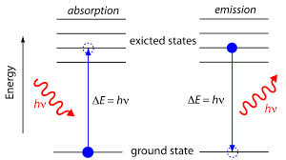

of

Atoms or molecule

ΔE corresponds to certain frequency (ν ) or wavelength (λ) of electromagnetic radiation.

⇒ This depends on the type of transition and hence separation between the energy levels.

λ = 1/ῡ = c/ν (m, μm, nm) ⇒ Wavelength

ῡ = 1/λ = ν/c (m-1, cm-1) ⇒ Wave number

ν = c/λ = cῡ (s-1, Hz) ⇒ Frequency

1 nm = 10-7 cm

Measuring energy levels gives means of identification ⇒ spectroscopy

**Electromagnetic Spectrum**

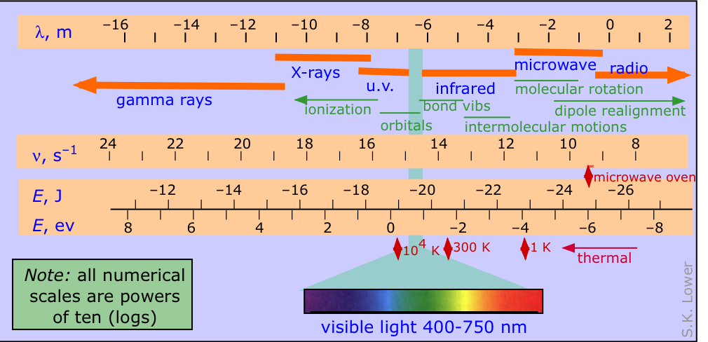

[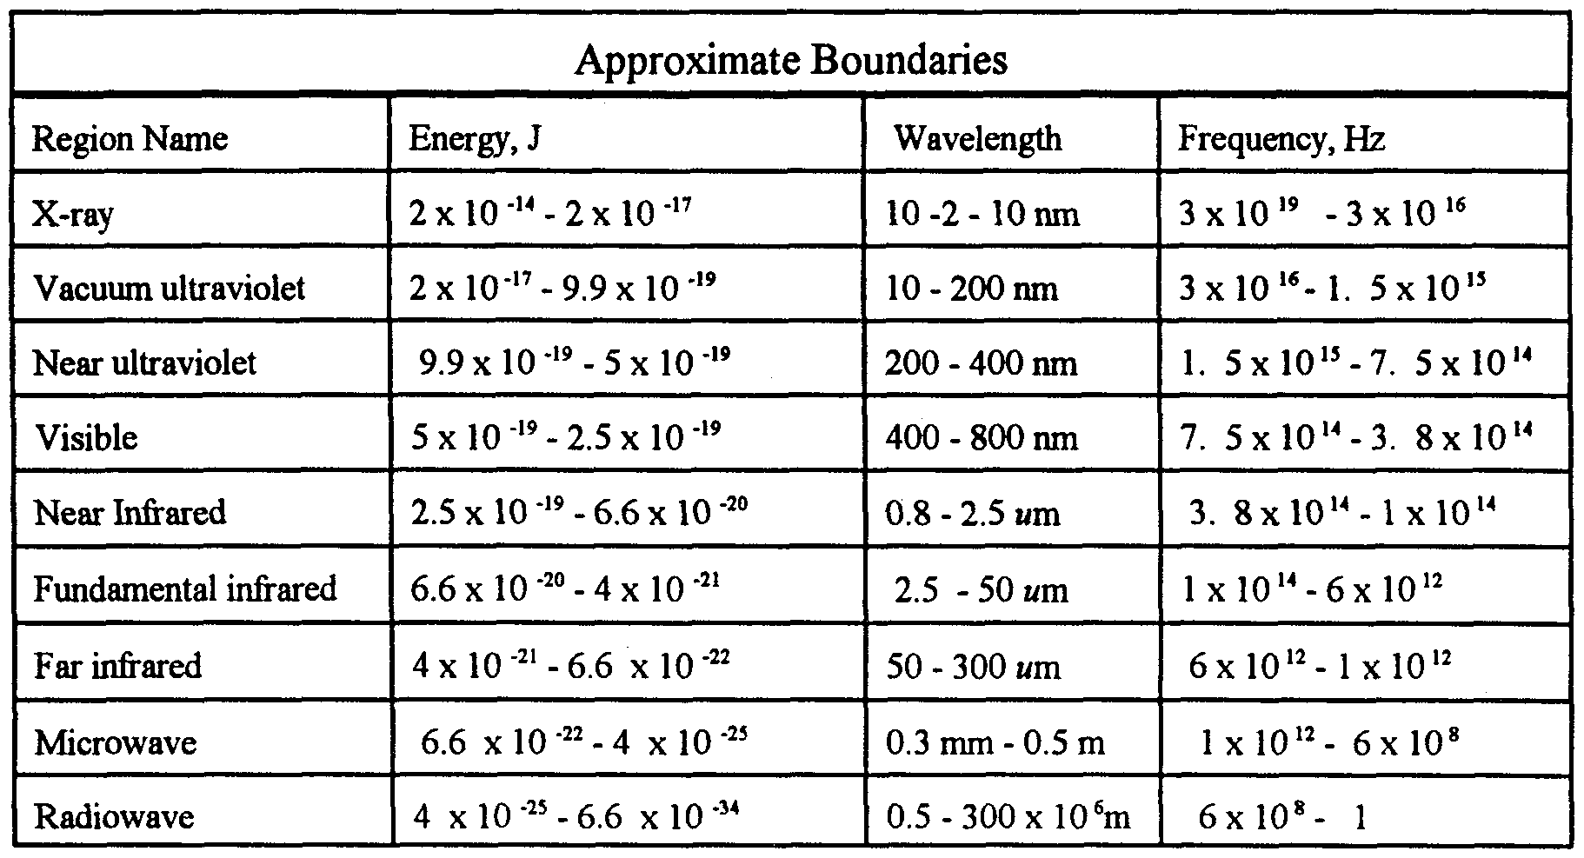](http://www.google.com/url?sa=i&rct=j&q=&esrc=s&source=images&cd=&cad=rja&uact=8&ved=0ahUKEwiHzdn_kaDOAhUBvxQKHa-TAXIQjRwIBw&url=http://www.google.com/patents/WO1998057736A2?cl=en&psig=AFQjCNHumbIBxaPsrK6NaRx5_AEUdmQpdg&ust=1470138233616014)

**NB:**

1. NMR transition ⇒ smallest gap between energy levels
2. UV – Vis ⇒ largest gap between transition levels
3. X – rays ⇒ high energy capable of ionizing atoms and molecules
4. Microwaves (rotational) spectra are very complex and give little useful information on organic molecules, which are relatively large.
5. Rotational transitions are often responsible for the broadness of IR bands, since each vibrational transition has a number of rotational transitions associated with it.
6. Transitions in UV – Vis, IR and NMR are governed by selection rules that state which transitions are “allowed” and which are “forbidden”.

**Double bond equivalent [DBE, (Ω)]**

* tells how many double bonds or rings are present in a molecule
* each double bond or ring reduces number of hydrogen (or halogens) atoms by two.
* Compare with fully saturated acyclic molecule

DBE = (C + 1) - [(H* - N)/2]

number of number of number of

carbon atoms hydrogens or nitrogen atoms

halogens

OR: For CnHmO ; DBE = $\frac{\left(2n+2\right)- m}{2}$

For CnHmNp  ; DBE = $\frac{\left(2n+2\right)- (m-p)}{2}$

e.g. **For C6H7NO**; DBE = (6 + 1) – = 7 – 3 = 4

OR: DBE = = = 4

For **C5H10O2**

DBE = = 1

OR: (C + 1) - [$\frac{H^{*}- N}{2}]$

DBE = 6 - [10/2] = 6 – 5 = 1

Problem

The local anaesthetic benzocaine has a molecular formula C9H11NO2

Calculate the number of double bond equivalents and identify all the double bond equivalents in benzocaine.

**Answer**

DBE = [(2x9 + 2) – (11 – 1)] = 5

2

OR DBE = (9 + 1) – [11 – 1]/2 = 5

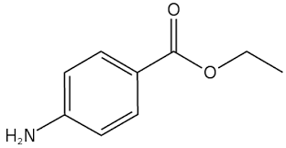**4 double bonds + 1 ring**

Ultraviolet – Visible (UV – Vis) Spectroscopy (also electronic spectroscopy)

* UV light ⇒ 200 – 400 nm ; 595 – 299 KJ mol-1
* Vis light ⇒ 400 – 900 nm ; 299 – 149 KJ mol-1

⇒ Promotion of outer electrons from one electronic energy level to a higher one.

⇒ Difference between electronic levels is greater than the difference between any other

molecular energy levels.

⇒ Region below 200 nm ⇒ vacuum UV purged with N2 since O2 absorbs strongly in this

region.

**Important of UV - Vis**

⇒ ability to measure the extent of multiple bonds or aromatic conjugation within a molecule.

⇒ nonbonding electrons (n) on oxygen, nitrogen, and sulphur can also extend the conjugation of

multiple bonds.

**Frank – Condon Principle ⇒ Nuclei are much massive than electrons, so electronic transitions take place faster than nuclei can respond.**

* Most intense vibronic transition is from the ground vibrational state to the vibrational state lying vertically above it.
* Transitions to other vibrational levels also occur, but with lower intensity.

Relative energies of orbitals most involved in electronic spectroscopy

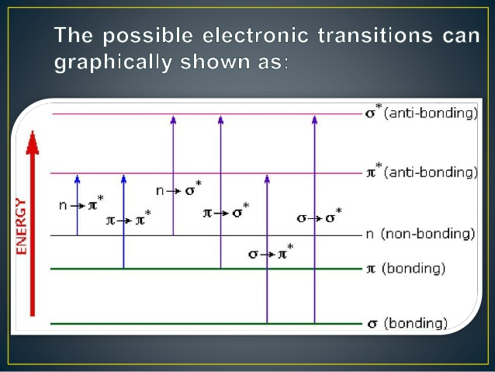

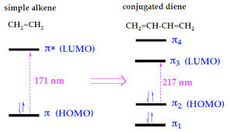

⇒ Not all transitions are allowed.

**⇒ allowed if: 1. Orientation of the spin does not change during the transition**

**2. Symmetry of the initial and final functions is different**

These are referred to as the spin and symmetry rules.

**NB:** forbidden transitions have low probability and give weak absorptions (low intensity)

**Beer–Lambert Law**

Beer’s (relates absorption to concentration of absorbing solute)

Lambert’s (relates total absorption to the optical path length)

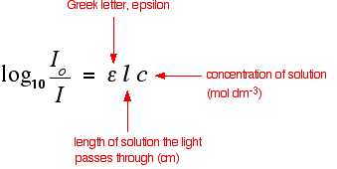

**Absorbance (A) = log10 =**

**(optical density)**

I0 is the intensity of incident light

I is the intensity of light transmitted through the sample solution.

### Instrumentation

### http://www.sci.sdsu.edu/TFrey/Bio750/UV-Vis4.gif

Experimental measurements are usually made in terms of **transmittance** (T), which is defined as:

T = I / Io

Where I is the **light intensity** after it passes through the sample and Io is the **initial light intensity**. The relation between A and T is:

A = -log T = - log (I / Io).

The ratio of the intensity of the light entering the sample (Io) to that exiting the sample (It) at a particular wavelength is defined as the transmittance (T). This is often expressed as the percent transmittance (%T), which is simply the transmittance multiplied by 100. The absorbance (A) of a sample is the negative logarithm of the transmittance.

% T = (Io / It ) x 100  
  
A = - log (T)

**NB: Ethanol is transparent to UV above 200 nm hence used as solvent in UV–Vis spectroscopy**

$∈ = \frac{A}{Cl}$

Molar absorptivity (molar extinction

Coefficient) ⇒ (lmol-1 cm-1 or 100 cm2 mol-1 or dm3 mol-1 cm-1)

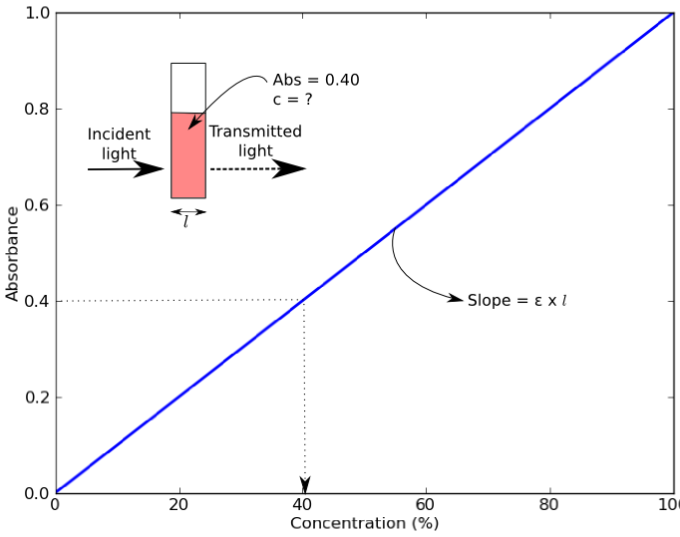

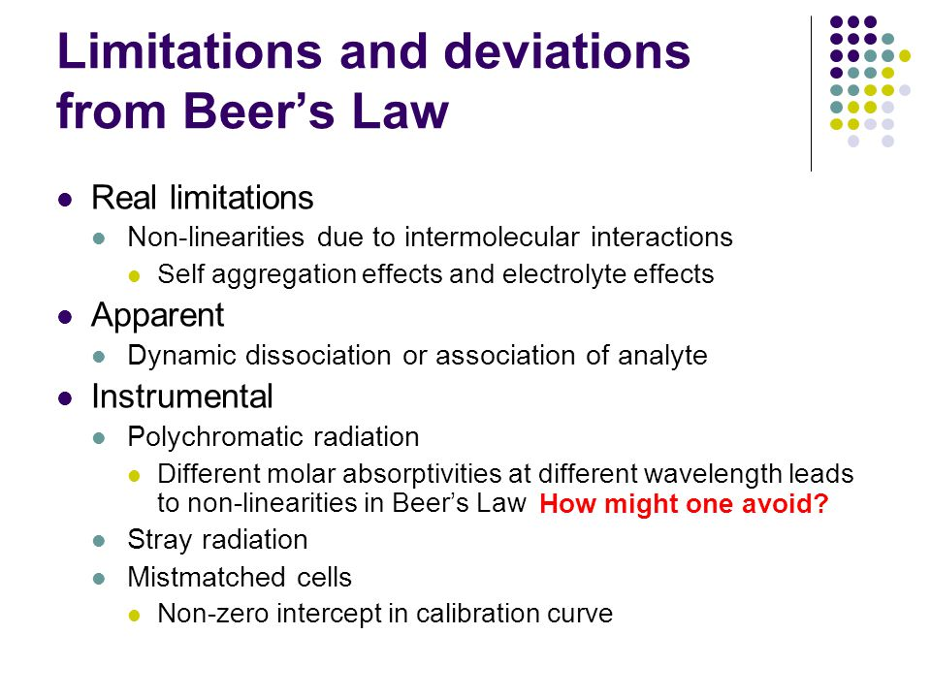

**Limitations of the Beer-Lambert law**

The linearity of the Beer-Lambert law is limited by chemical and instrumental factors. Causes of nonlinearity include:

* deviations in absorptivity coefficients at ***high concentrations (>0.01M)*** due to electrostatic interactions between molecules in close proximity
* **scattering of light due to particulates** in the sample
* **fluoresecence or phosphorescence** of the sample
* changes in refractive index at high analyte concentration
* shifts in chemical equilibria as a function of concentration
* non-monochromatic radiation, deviations can be minimized by using a relatively flat part of the absorption spectrum such as the maximum of an absorption band
* stray light

**Limitations decreased by:**

* relatively dilute samples
* Avoid turbid samples
* Need to avoid scattering
* Fixed single wavelength/fixed temperature

ε⇒ constant for a particular compound at a given wavelength and mostly expressed as εmax

⇒ log10 ε max also used for large εmax values.εmax  > 104 (high–intensity absorption)

εmax < 103 (low–intensity absorption)

NB: If relative molecular mass, mr is unknown;

A = a x c x l: where a = absorptivity and c = concentration in gl-1

The Beer–Lambert law is most commonly used in UV – Visible absorption spectroscopy but can also be used with FT–IR

**Chromophore**

* Part of the molecule containing the electrons involved in electronic transitions which give rise to an absorption.

OR: Covalently unsaturated group responsible for electronic absorption

⇒ Wavelength of the maximum of the broad absorptions is labeled λmax.

Non–conjugated chromophores

|  |  |  |  |
| --- | --- | --- | --- |
| λmax (nm) | εmax(10-2m2mol-1) | chromophore | Transition causing absorption |
| ~ 150 |  | C-H or C–H δ-bonded electrons | δ → δ* |
| ~ 185 – 195 |  | -X: (X = O, N, S) lone pair of electrons | n → δ* |
| ~ 300  ~ 190  ~ 160 | 15  5,000  18,000 | C=O:  Lone pair electrons | n → π* (symmetry forbidden, low intensity)  n → δ*  π → π* (most intense but needs high energy) |
| ~ 190(~175) |  | C=C (isolated) π-bond electrons | π → π* |

* Intensity of the major absorption (and of course the ε value) increases as the chromophore increases in length.
* Systems with a higher degree of conjugation have greater intensity absorption bonds with larger ε values.

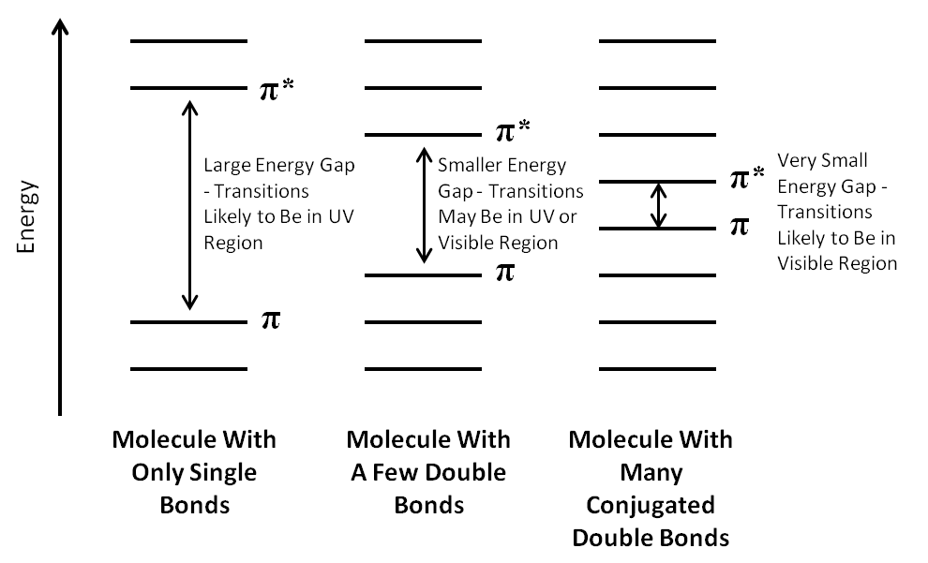

* Increased conjugation decreases the energy difference between the HOMO and the LUMO of a particular system ⇒ less energy needed for transition.
* The longer the chromophore, the longer the wavelength of the absorption maximum.

E.g. But-3-en-2-one (methyl vinyl ketone, MVK): π → π*; λmax = 219nm and εmax = 3600

n → π* ; λmax = 324nm and εmax = 24

Propanone: π → π*; λmax = 187nm and εmax = 900

n → π* ; λmax = 270nm and εmax = 15

**NB: n → π* is symmetry forbidden.**

Intense band ⇒ K – band (π → π* )

Less intense band ⇒ R – band ( n → π* )

* Increase in the λmax towards the red end of the spectrum is call a red shift ( shift to longer λ, lower energy) or a **bathochromic shift**

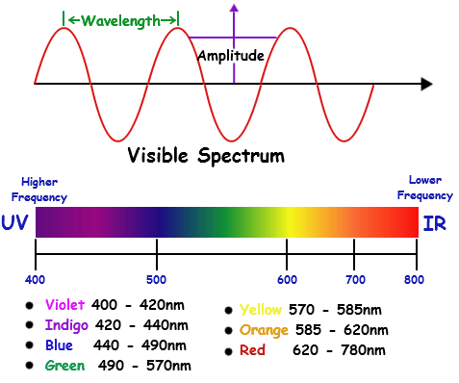

**VIBGYOR**

* Shift to shorter wavelength (higher energy) is called blue shift or a **hypsochromic shift.**
* Shift can be due to substitution or solvent effect
* **Hyperchromic effect** ⇒ increase in absorption intensity
* **Hypochromic effect** ⇒ decrease in absorption intensity
* **Auxochrome** ⇒ a saturated group with non–bonded electrons which when attached to a chromophore, alters both the wavelength and intensity of absorption e.g. –OH, -NH2, -Cl

**Solvent Role**

The Franck–Condon Principle states that the electronic transitions involve the movement of electrons, including those of the solvent, but not the movement of atoms.

When the solvent electrons can rearrange to stabilize the excited state of a molecule, the energy different between the electronic levels of the molecule is lowered and the absorption moves to higher wavelength.

**NB:**

1. Conjugated dienes and aromatic hydrocarbons ⇒ very little solvent shift.
2. α,β - unsaturated carbonyl compounds:-
3. π → π*  band moves to longer wavelength (red shift)
4. n → π* band moves to shorter wavelength (blue shift)

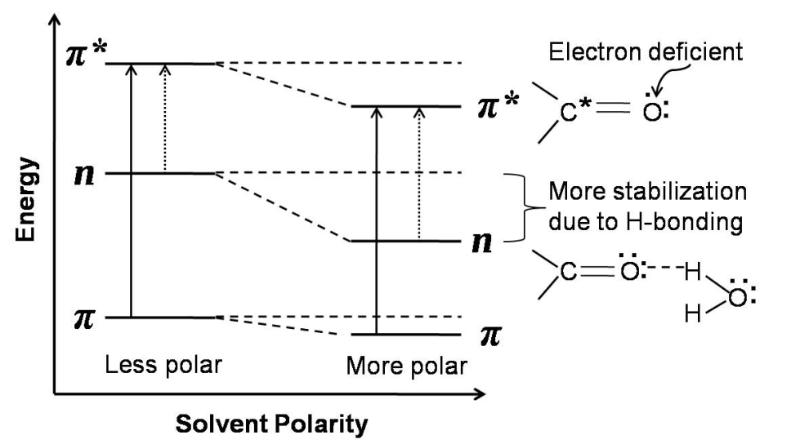

⇒ due to solvation, stabilizes π, π* and n-orbitals especially with H–bonding solvents e.g. EtOH, H2O etc.

⇒ π* are more stabilized by salvation then π- orbitals ⇒ presumably because π* orbitals are more polar.

⇒ Interaction of the lone pair with solvent lowers the energy of n–orbital ⇒ increases energy required for n → π*

π → π* > πs → π*s ⇒ moves to longer wavelength

⇒ red shift

⇒ less energy

n → π* < ns → π*s ⇒ moves to shorter wavelength

⇒ blue shift

⇒ more energy

**Effect of pH**

e.g.

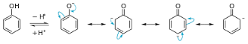

(neutral or phenoxide anion

Acidic conditions) (Basic conditions)

λmax (H2O) 210 (6,000) λmax (H2O) 235 (9,400)

270 (1,500) 287 (2,600)

⇒ Increased conjugation of the lone pairs on oxygen with the π-system of the aromatic ring.

⇒ leads to decrease in the energy difference between the HOMO and LUMO orbitals

⇒ red(bathochromic) shift ⇒ shift to longer wavelengths and increase in the intensity of absorption.

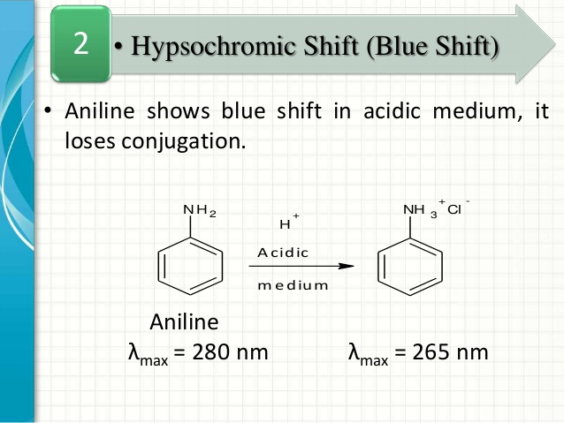

Aniline Protonated aniline

(Neutral or basic conditions) (Acidic conditions)

λ max (H2O) 235 (14,800) λ max (H2O) 203 (7,500)

285 (2,800) 254 (180)

⇒ loss in overlap between the amine lone pair

and the aromatic π system

⇒ blue(hypsochromic) shift

⇒ shifts to shorter wavelength and a decrease in

intensity of absorption

**Phenolpthalein**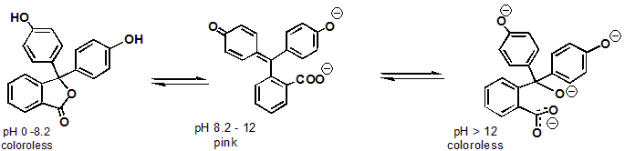

π → π*  λmax 231 nm(εmax 25800) λmax 230 nm(εmax 25800)

n → π* λmax 275 nm (εmax 4200) λmax 553 nm (εmax 3600)

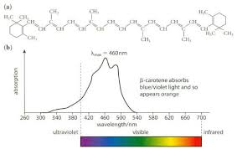

**Woodward – Fieser Rules**

* Many classes of compounds show regularities in their absorption spectra ⇒ enables calculations to be possible for λmax.
* Used in structure determination by distinguishing between two or more isomers.

**3 systems**

* Acyclic dienes or dienes contained in non-fused ring systems
* Dienes or polyenes in fused ring system
* Conjugated enones and dienones

Parent acyclic dienes (not homoannualr) - 217(215) nm

Parent homoannular dienes - 253 nm

Parent heteroannular dienes - 214 (215) nm

Parent acyclic trienes - 245 nm



**NB:**

1. Delocalization of electrons by conjugation decreases the energy difference between HOMO and LUMO energy levels ⇒ leads to a red shift.
2. Alkyl substitution on a conjugated system leads to a smaller red shift.

⇒ interaction between δ - bonded electrons of the alkyl group with the π - bond system.

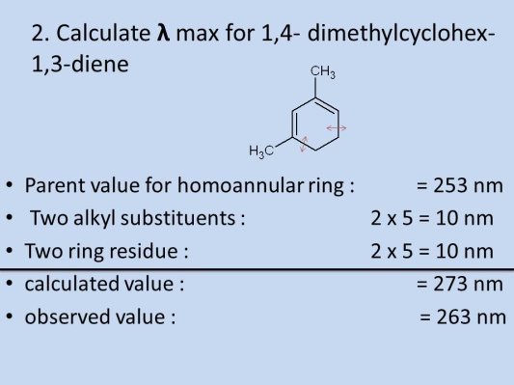

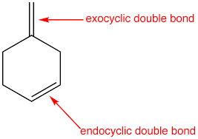

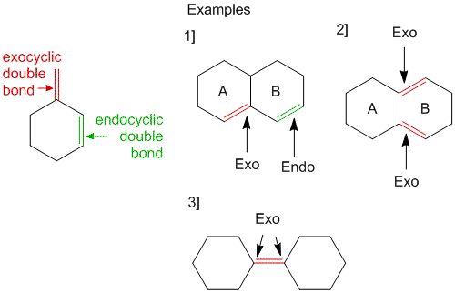

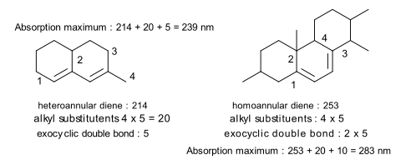

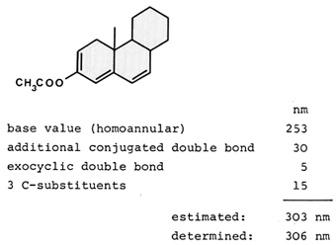

**NB:** Reduction in effective conjugation raises the energy requirement for π→π* transitions.

* λ max (calc) for strained dienes do not agree with the observed values.



* ⇒ Woodward-Fieser Rules work well up to 4 double bonds.
* ⇒ for more than 4 conjugated double bonds: Fieser-Kuhn Rules
* λmax = 114 + 5(# alkyl substituents) + n(48 - 1.7n) - 16.5(# endo) - 10(# exo)

OR

λmax = 114 + 5m + n (48 – 1.7 n) – 16.5 Rendo – 10 Rexo

λmax  = (1.74 x 104)n

n = no. of conjugated double bonds

m = no. of alkyl or alkyl like substituents on the conjugated system

Rendo = no. of rings with endocyclic double bonds in the conjugated system

Rexo = no. of rings with exocyclic double bonds

**For example, Lycopene ⇒ deep – red compound that is partially responsible for the red colour of ripe fruits especially tomatoes.**

**Lycopene and beta-carotene**

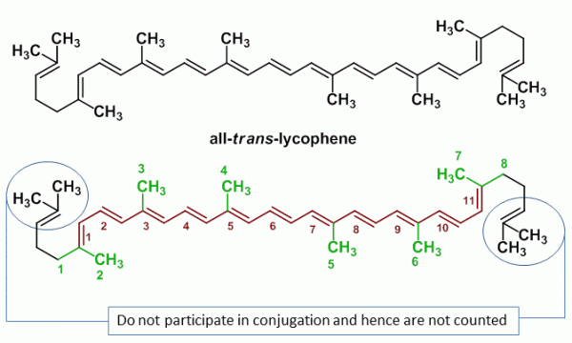

* λmax = 114 + 5(8) + 11(48 - 1.7•11) - 0 - 0 = 476 nm
* λmax (actual) = 474 nm

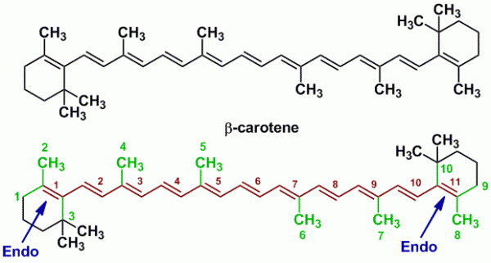

* λmax = 114 + 5(10) + 11(48 - 1.7•11) - 16.5(2) - 0 = 453.3 nm
* λmax (actual) = 452 nm

**α, β - Unsaturated carbonyl compounds (in EtOH)**

λmax for π → π* ⇒ K-band

π → π* > πs → π*s

Red shift





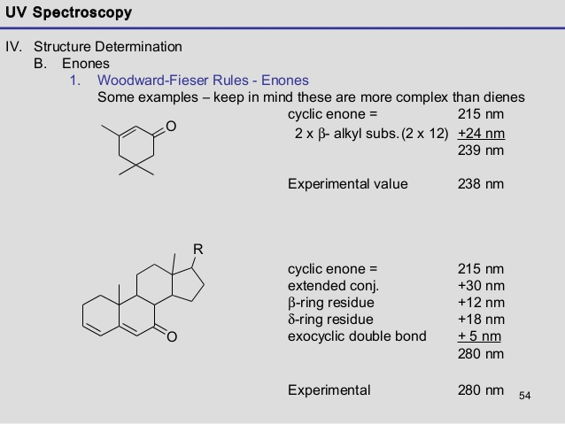

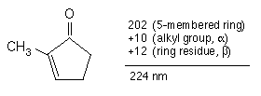



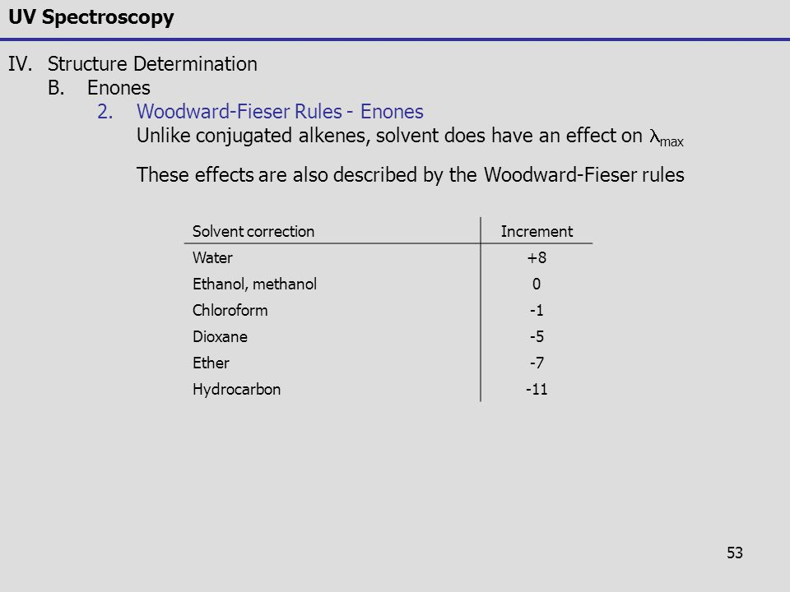

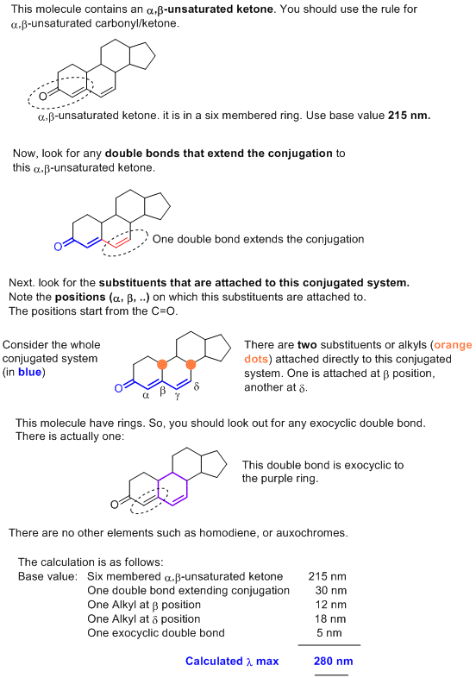

**Substituted benzene derivatives**

**Scott’s rule: e.g.**



**Stereochemical factors in electronic spectroscopy**

* Angular strain or steric overcrowding

⇒ distorts geometry of the chromophore

⇒ reduced π - orbital overlap ⇒ reduced conjugation

**e.g. Biphenyls:**

[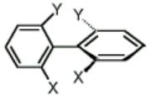](http://www.google.com/url?sa=i&rct=j&q=&esrc=s&source=images&cd=&cad=rja&uact=8&ved=0CAcQjRxqFQoTCOyukubP-8cCFQgK2wodYBMAbw&url=http://www.searlescholars.net/person/274&bvm=bv.102829193,d.ZGU&psig=AFQjCNEEMYSaydfPhODFK3o9f7qPnOU7Tw&ust=1442495153161573)

Leads to shorter wavelength shift and diminished intensity.

**Cis- and trans- isomers**

Alkenes: ⇒ trans- isomer exhibits longer wavelength absorption and higher intensity than cis – isomer.

**Angular distortion**: ⇒ steric inhibition of conjugation.



E.g.



**Quantitative electronic spectroscopy**

$∈$ = A/Cl

⇒ Can find concentration of a chromophoric molecule in solution provided value of ε is

known.

⇒ Working curve from a series of solutions of known concentration.

e.g Plot absorbance at a fixed wavelength against known concentration of standards.

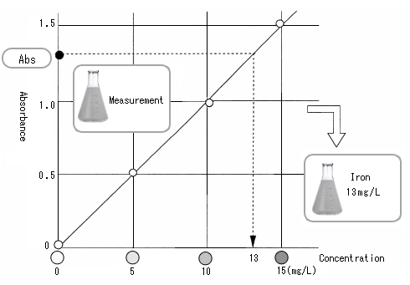

**UV detection used in TLC and HPLC ⇒ quality control in the pharmaceutical industries.**

**Infra red spectroscopy (IR)**

Wavenumber (ῡ) ⇒ number of waves(cycles) per centimeter (cm-1)

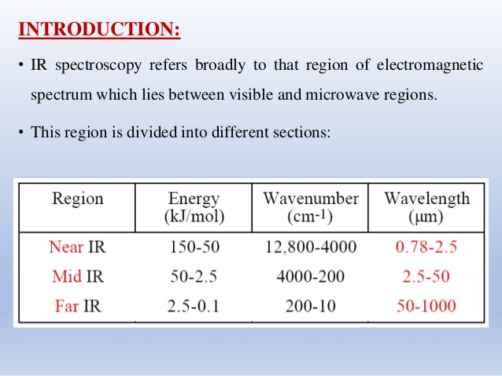

20,000 -------- 4,000-----1350--------------650--------200---------10 cm-1

Near IR Far IR (pure rotational region)

(overtone region) Group finger print region

frequency

**Vibrational IR**: 4000 to 400 cm-1

**Hooke’s Law**

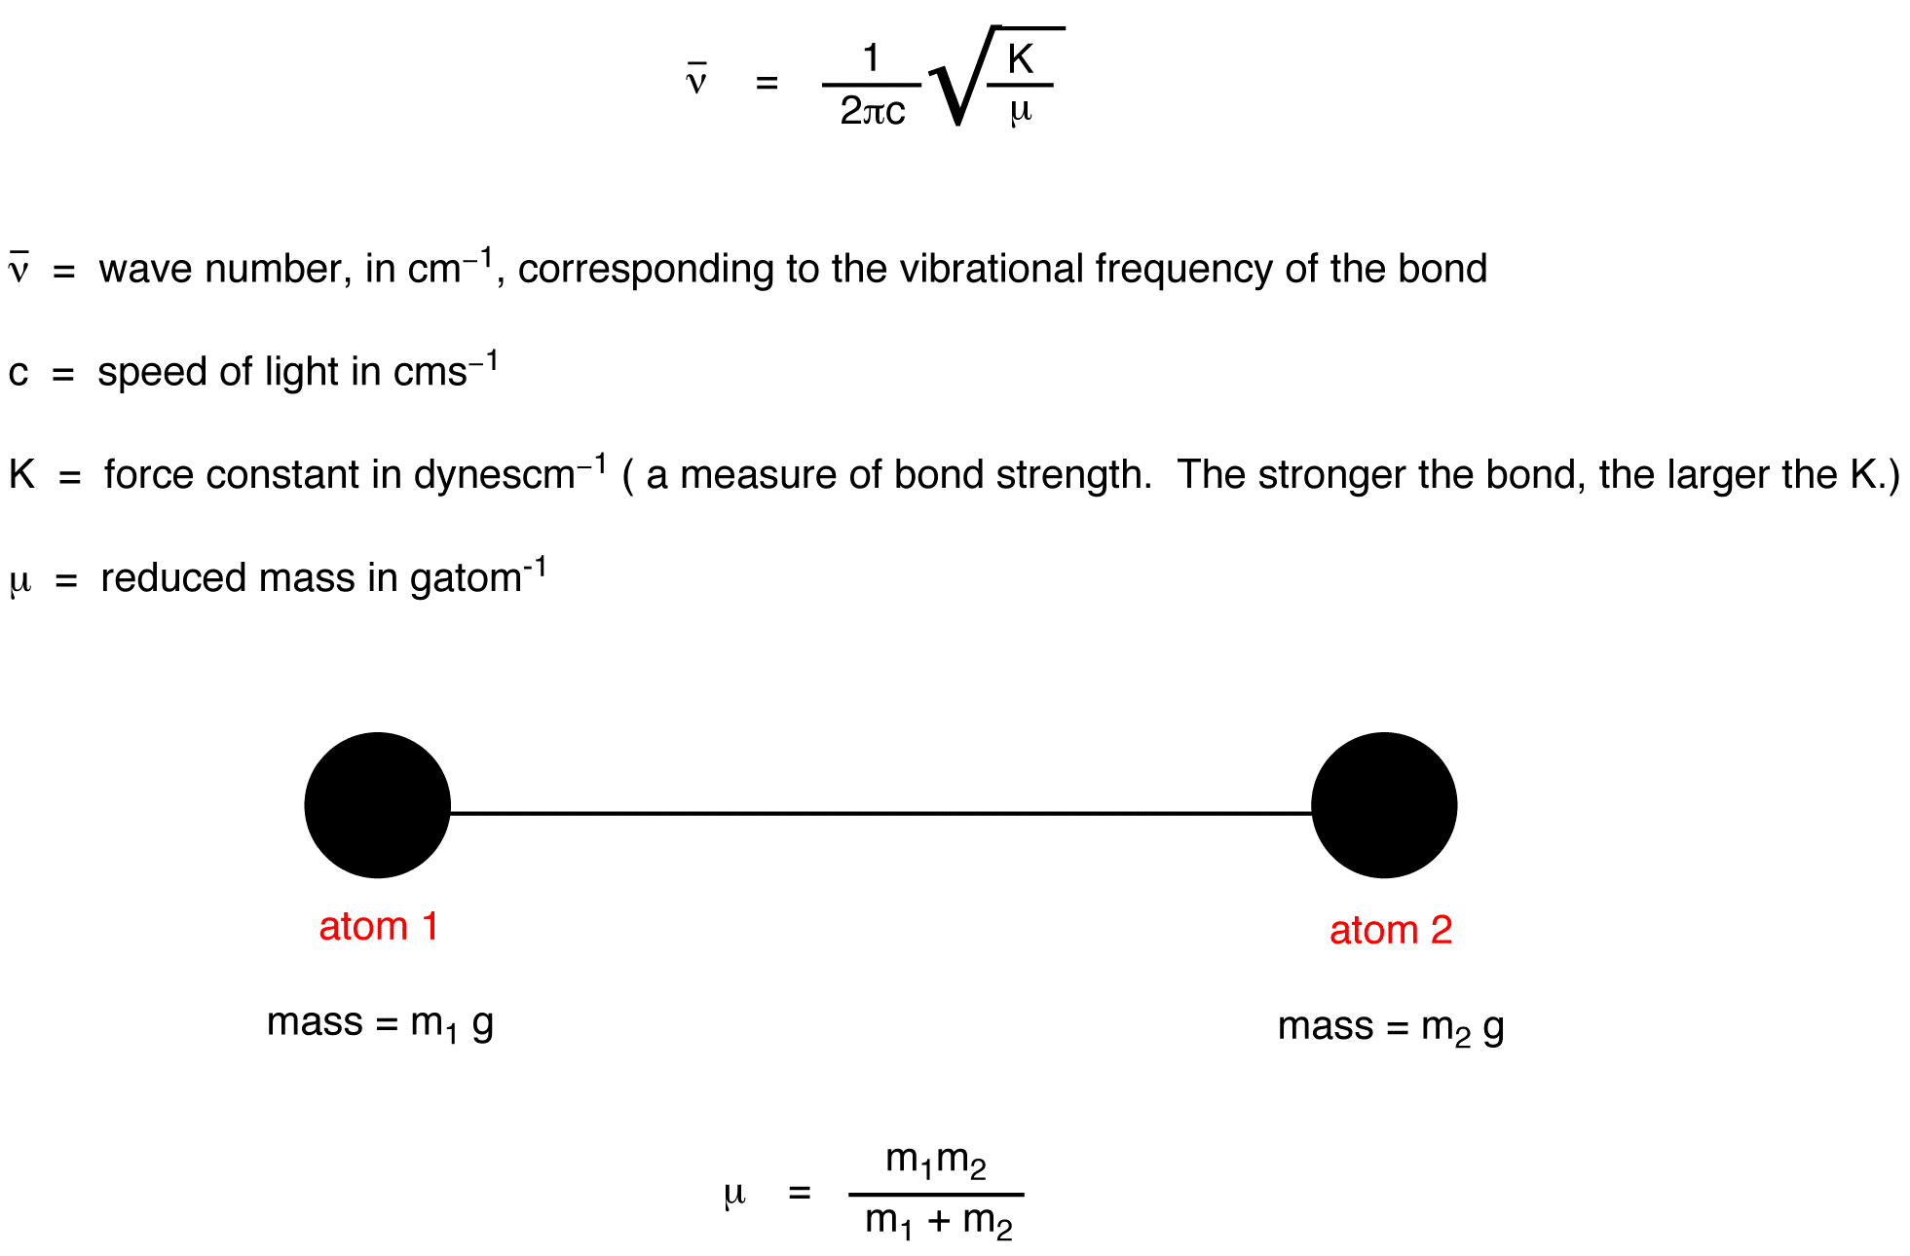

e.g. force constants of C – H and C – C bonds are similar but the m1 + m2/m1m2 term for C-H bond is 8.0 x 1011 compared with 3.2 x 1011 for C-C bond.

⇒ X–H ⇒ highest frequencies.

Bond strength: (bond order)

C≡C > C=C > C-C

C=O > C-O

Stretching and bending vibrations of bonds in organic molecules e.g. -CH2- , -NH2

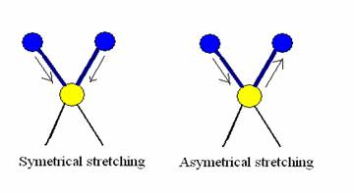

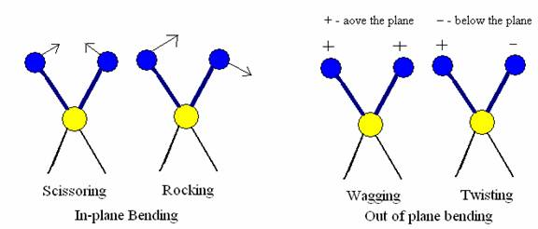

* Pass a bean of infrared radiation of constantly varying frequency through a sample of the compounds.
* Detector generates a plot of % transmission of radiation versus wave number or wavelength of the transmitted radiation.
* Each spike (absorption band) represents absorption of energy.

Sample

1. Gas ⇒ gas cells
2. Liquid ⇒ thin film on NaCl cells

⇒ solutions

1. Solids ⇒ KBr pellets (disc)

0.1 – 2% by weight with KBr

⇒ Mulls → pastes → using liquids paraffin (Nujol) but interference because of

C–Hstretching and C-H bending.

⇒ use hexachlorobutadiene (HCB)

⇒ C=C interference

⇒ use chlorofluorocarbon oils

**Factors influencing vibrational frequencies**

1. **Vibrational Coupling**

* For isolated C–H bond ⇒ one stretching vibration frequency

⇒ C–H in –CH2- ⇒ stretching vibrations combine to give 2 coupled vibrations of different frequencies ⇒ ῡsym and ῡasym

**NB:** Vibrational coupling takes place between two bounds vibrating with similar frequency, provided that the bonds are reasonably close in the molecule.

* Coupling of stretching and bending vibrations e.g. secondary acyclic amides (exists predominantly in the trans–conformation) show strong absorption in the 1650–1515 cm-1 region ⇒ involves coupling of N–H bending and C=O stretching vibrations.

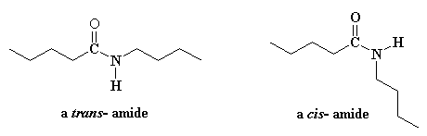

~1650 cm-1 ⇒ mainly due to C=O str. ⇒ amide I band

~1515 cm-1 ⇒ mainly due to N-H def. and C-N str. coupling ⇒ amide II band.

* Coupling accounts for the two N–Hstr bands in the 3497-3077 cm-1 region in primary amines and primary amide spectra.
* Also for the two C=O str bands in the 1818–1720 cm-1 region in carboxylic acid anhydrides (with separation of about 65 cm-1).

[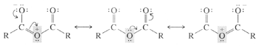](http://www.google.com/url?sa=i&rct=j&q=&esrc=s&source=images&cd=&cad=rja&uact=8&ved=0CAcQjRxqFQoTCPCd4f6ejcgCFQIq2wodJmUNWA&url=http://www.slcc-science.org/chem/giddings/chem2320/ch20/20_index.htm&bvm=bv.103388427,d.eXY&psig=AFQjCNEkcLmkJkX8tI-VVJUiVNXselYEEg&ust=1443100598404480)

⇒ Coupling between the two carboxyl groups via oxygen ⇒ coplanar system.

⇒ higher frequency band ⇒ sym C=O stretching.

**Fermi Resonance ⇒ Enrico Fermi**

⇒ fundamental vibrations may couple with the overtone of some other vibration ⇒ Fermi

resonance.

e.g. “doublet” appearance of C=O str. of cyclopentanone.

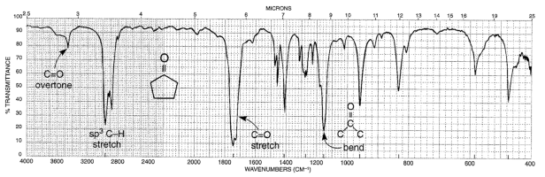

1st overtone of C–H bend and C=O stretching.

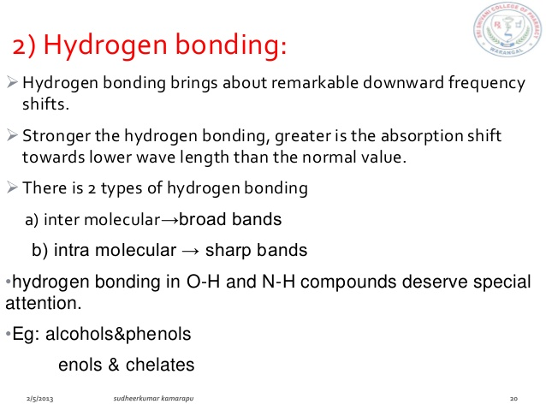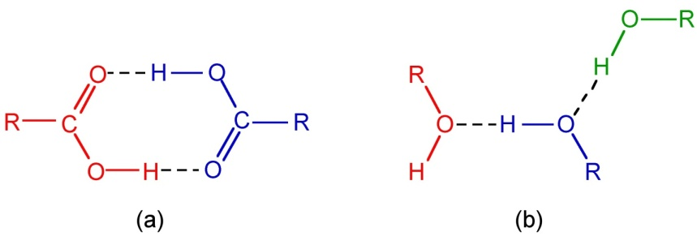

⇒ alters force constant of both groups

[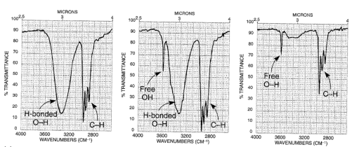](http://www.google.com/url?sa=i&rct=j&q=&esrc=s&source=images&cd=&cad=rja&uact=8&ved=0CAcQjRxqFQoTCKfo3Y2Nj8gCFULWGgodqkwCog&url=http://chemistrytextbookcrawl.blogspot.com/2012/12/infrared-spectra-of-alcohols-and-phenols.html&psig=AFQjCNHaXC01oMNfVapDqLzZc_ynibezgQ&ust=1443164434420986)

X–Hstr. ⇒ moves to lower frequencies usually with increased intensity and broadening.

Free O–H str.: 3650 cm-1 (sharp)

Hydrogen–bonded O–H str.: 3350 cm-1 (broad)

* Intramolecular H-bonding not affected by dilution.

**Enols**

e.g. 2, 4 – pentanedione

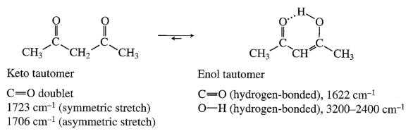

**3. Electronic effects**

* Changes in the absorption frequencies for a particular group take place when the substituents in the neighbourhood of that particular group are changed.

It includes:

* Inductive effects
* Mesomeric effects (resonance)
* Field effects (through space influence)

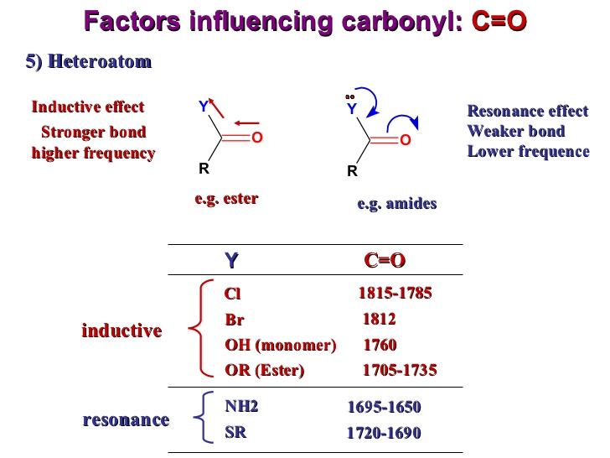

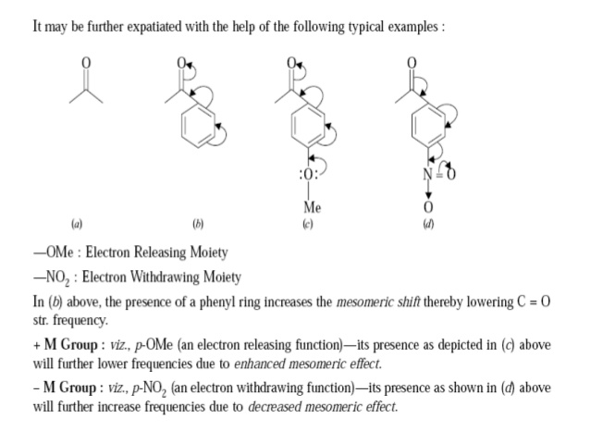

 Field effects ⇒ electrostatic and/ or steric in nature.

E.g.



1. **Bond angles**

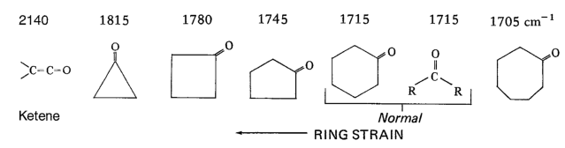

Strained bond-angle ⇒ higher C=O str freq.

If bond > 120o ⇒ opposite effects.

E.g.



**Application of IR ⇒ Identification of functional groups**

**Use of correlation tables**

**NB:** 1. 4000 – 1400 cm-1 and below 900 cm-1 ⇒ group frequency

2. < 1350 cm-1 ⇒ finger print region

**Alkanes:** C-H str 3000 -2840 cm-1

C-C str 1300 - 800 cm-1

**Alkenes:** =C-H str 3080 –3020 cm-1

(> 3000 cm-1)

C=C str 1667 –1640 cm-1

Conjugated: 1640 –1600 cm-1 (increased intensity)

**Alkynes:** ≡C–H str 3300 cm-1 (strong, sharp)

C≡C str 2140 – 2100 cm-1 (weak)

**Carbonyl Compounds**

Ketones, aldehydes, carboxylic acids and esters, lactones, acid halides, anhydrides, amides, lactams.

* C=O str ≈ 1870 – 1540 cm-1 (intense)
* Overtones at 2ῡ ≈ 3550 – 3200 cm-1 (weak)



**Amines**

10 ⇒ 3500 -3300 cm-1

(dilute solution, 2 bands, fairly sharp)

20 → 3500 -3300 cm-1

(one band, fairly sharp)

**Aromatic (mononuclear)**

* C-H str ≈ 3100 – 3000 cm-1 (weak)
* C-H bending ≈ 710 – 675 cm-1 (out-of-plane)
* C=C str (skeletal) ≈ 1600 – 1450 cm-1 (medium strength)

C – H def (bending) ⇒ out–of–plane



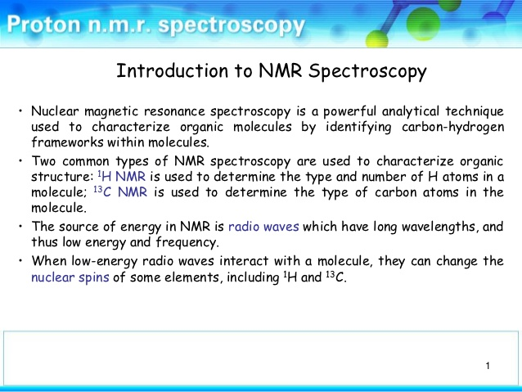

* 1H NMR
* 13C NMR

**Tell us about:**

* How many types of H atoms

⇒ groups of signals

* What types of H atoms

⇒ chemical shift

* How many H atoms of each type

⇒ integration

* What is the connectivity

⇒ coupling patterns

* Carbon skeleton

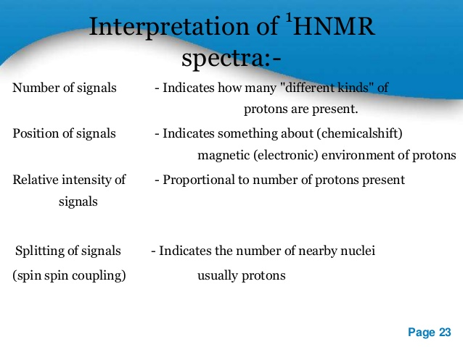

⇒ like an electron, a proton has two spin states with quantum numbers of +½ and -½.

⇒ depends on the absorption of energy when the nucleus of an atom is excited from its lowest spin state to the next higher one.

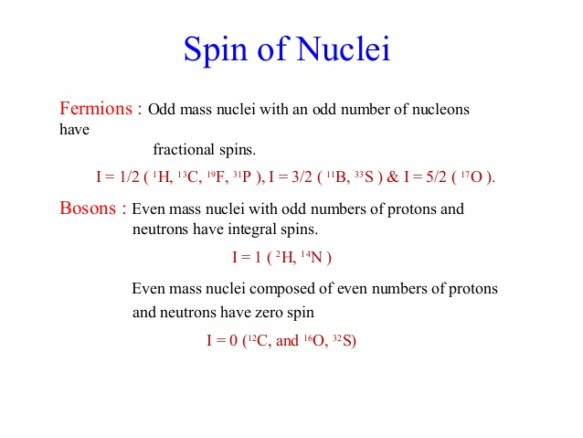

⇒ Nuclei isotopes possessing an odd number of protons or odd number of neutrons or both exhibit mechanical spin associated with spin angular momentum characterized by a nuclear spin quantum number I ≠ O

I = ½ n (n = 1, 2 etc)

e.g. n = 1; 1H; I = +½ or - ½

also 13C, 19F, 31P, 15N

n = 2 ⇒ I = 1 e.g. 14N and 2H

n = 3 ⇒ I = e.g. 11B

⇒ spinning proton behaves like a tiny bar magnet and has a magnetic moment associated

with it.

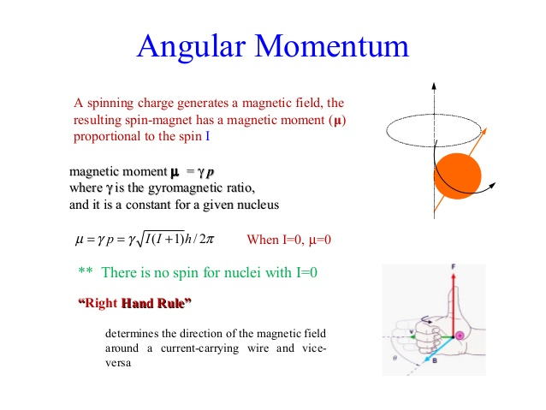

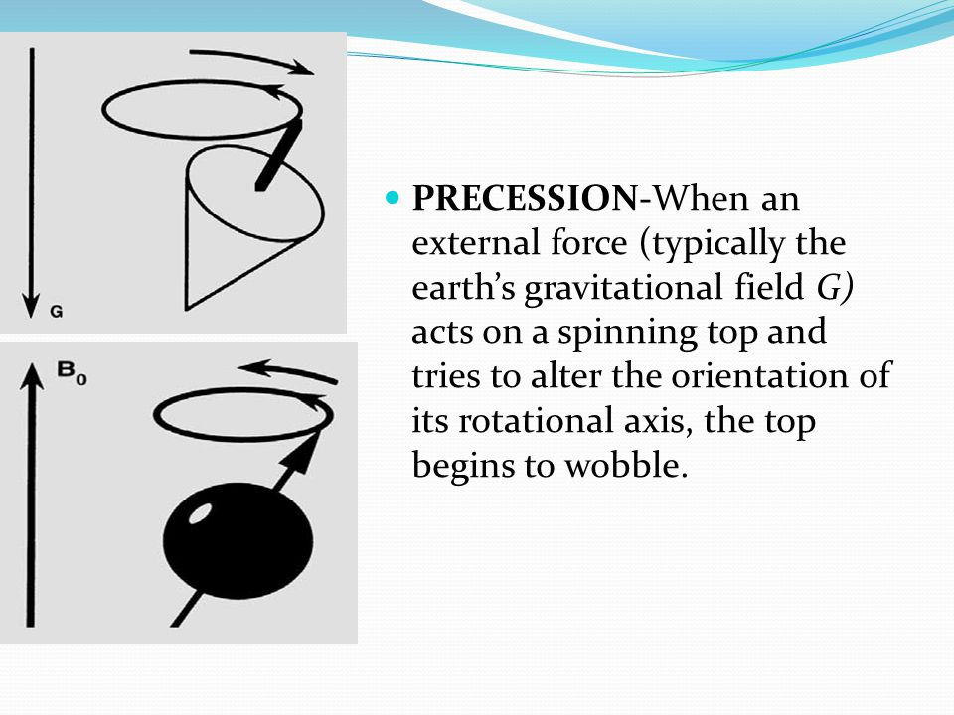

[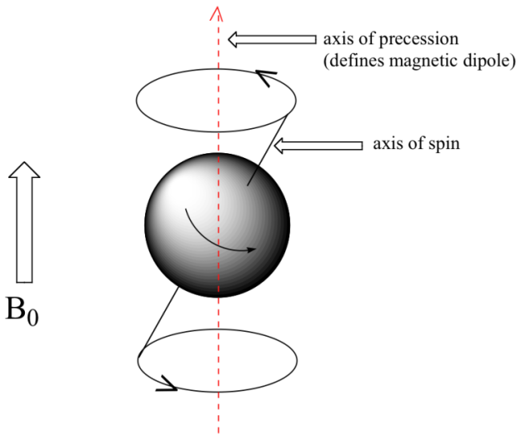](http://www.google.com/url?sa=i&rct=j&q=&esrc=s&source=images&cd=&cad=rja&uact=8&ved=0CAcQjRxqFQoTCIzs7_7Qw8gCFUddFAodPxMEFw&url=http://chemwiki.ucdavis.edu/Organic_Chemistry/Organic_Chemistry_With_a_Biological_Emphasis/Chapter_05:_Structure_Determination_II/Section_5.1:_The_origin_of_the_NMR_signal&psig=AFQjCNEjI-_6Awmq9jQjlzXn1i7qdd2RGw&ust=1444969487762293)

⇒ when placed in external magnetic field (Bo), a proton’s own magnetic field caused by the nuclear spin can align either with or against the external field.

**NB:** The nuclei can adopt (2I+1) orientations in the field with m1 (magnetic quantum number) values of -I, -I + 1, … , I.

Transitions with Δm1 = ± 1 are allowed ⇒ selection rules in NMR.

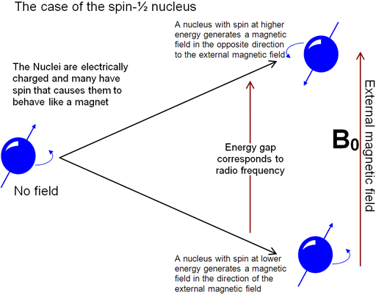

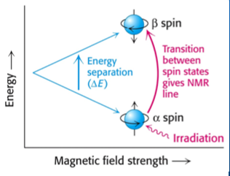

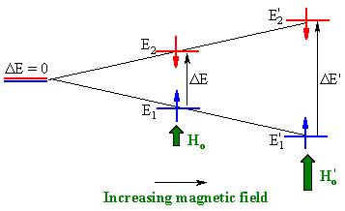

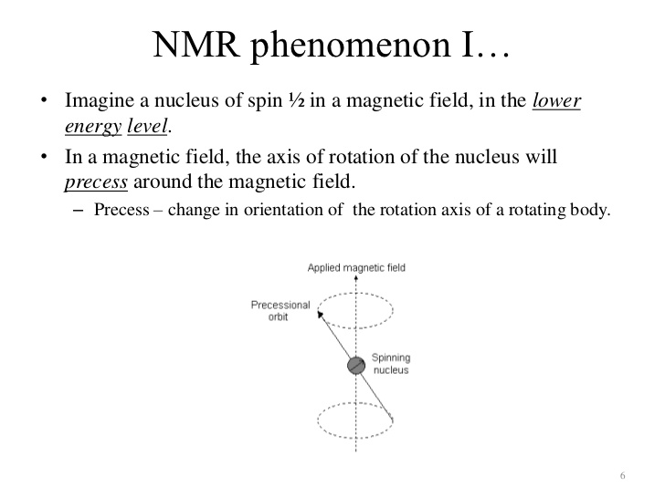

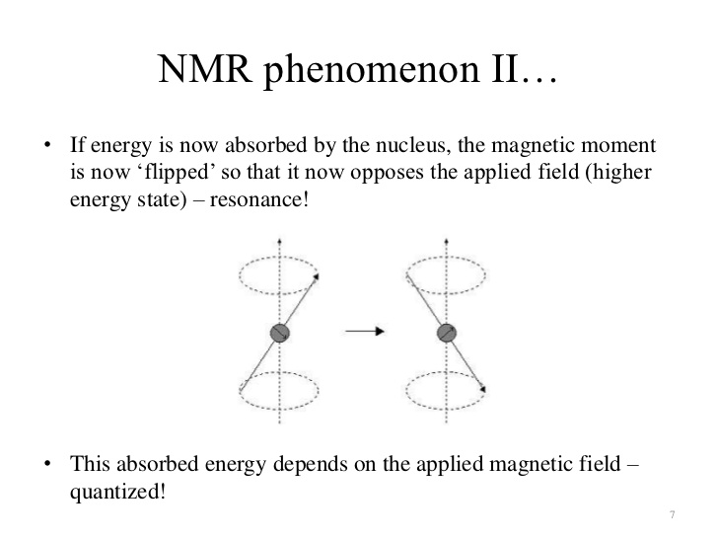

* Frequency of electromagnetic α Energy difference α Magnetic

radiation (Hz or s-1) between nuclear states field (T) (kjmol-1)

* If sample is irradiated with radiation in the radio–wave region (MHz), the proton can absorb the necessary energy and be promoted to the higher less–favourable state (spin

-½) ⇒ This absorption is called “resonance” since the frequencies of the applied radiation and the precession coincide or resonate.

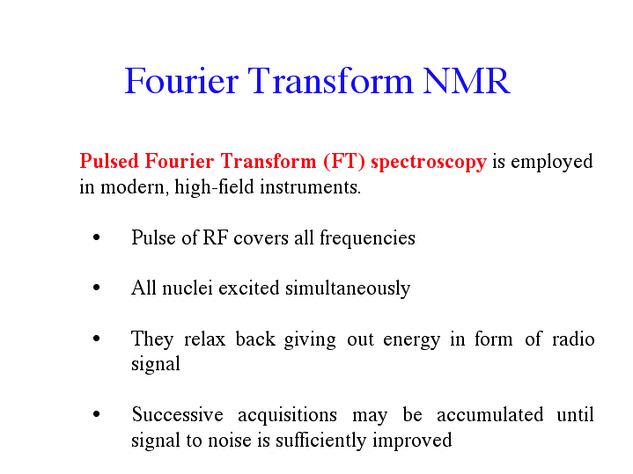

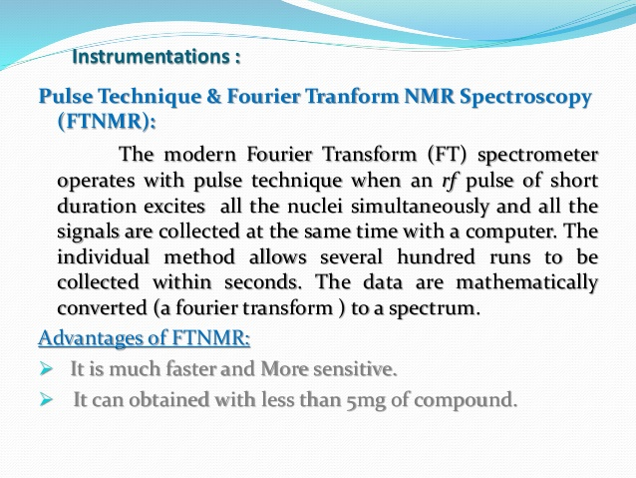

* Irradiate with short, intense burst of radiofrequency radiation (the pulse) which excites all the protons in the molecule at the same time.
* Free – Induction Decay (FID)

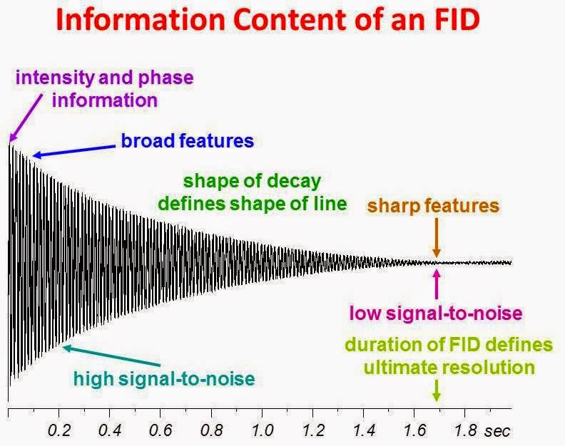

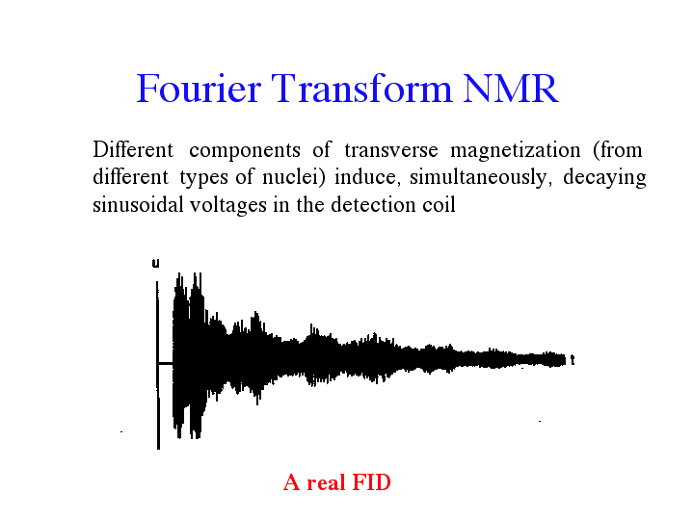

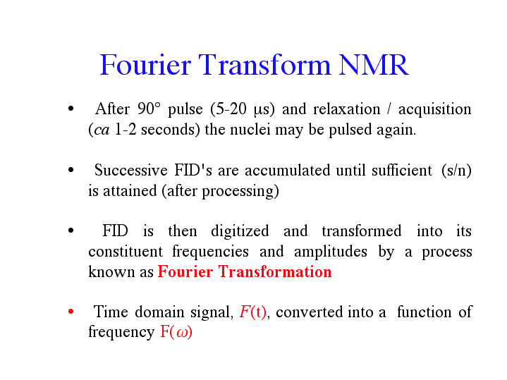

* FID stored in computer and converted into a spectrum by a mathematical process known as a fourier transform.

**Radiationless relaxations**

1. Spin-lattice relaxation ⇒ energy transferred to the molecule framework (“Lattice”) or solvent molecule (surrounding environment) and is lost as translational or vibrational energy (heat).
2. Spin–Spin relaxation ⇒ transfer of energy from one nucleus to the neighbouring nuclei, provided that particular value of ΔE is common to both nuclei.

**Chemical Shift**

* Electrons generate their own magnetic field which opposes and thus decreases the applied field (shielding effect).

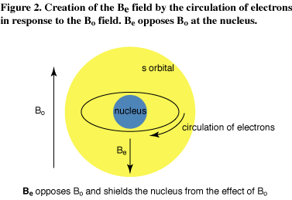

The term deshielding often used to describe the decreased shielding of one proton relative to another.

H = Ho(1 - σ) screening constant ⇒ screening effect related to chemical

environment of magnetic nucleus and type of chemical bonding involved.

applied magnetic field.

magnetic field experienced by nucleus.

* Shielding allows lower frequency to cause resonance

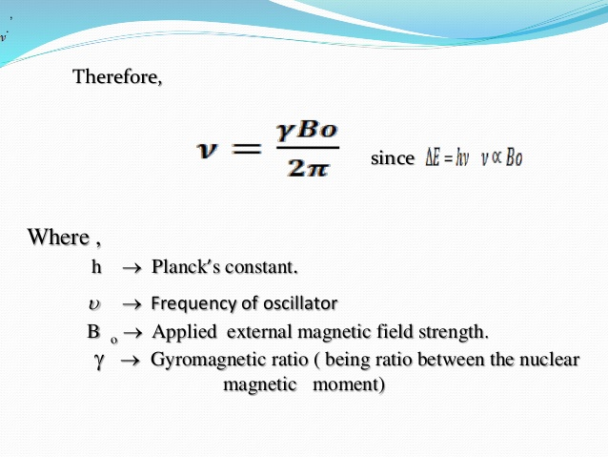

**γ is the ratio between the nuclear magnetic moment(μ) and the nuclear angular momentum(I) i.e. μ = γI**

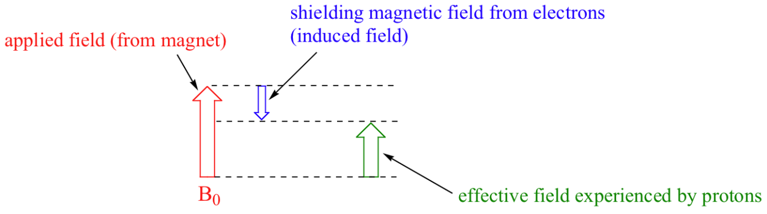

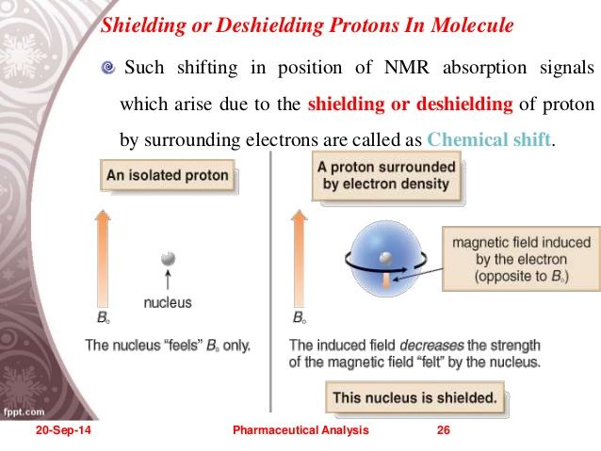

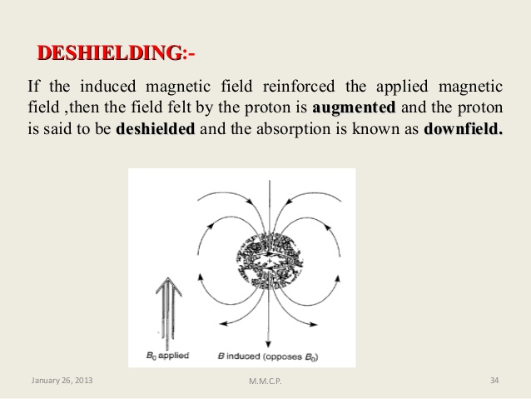

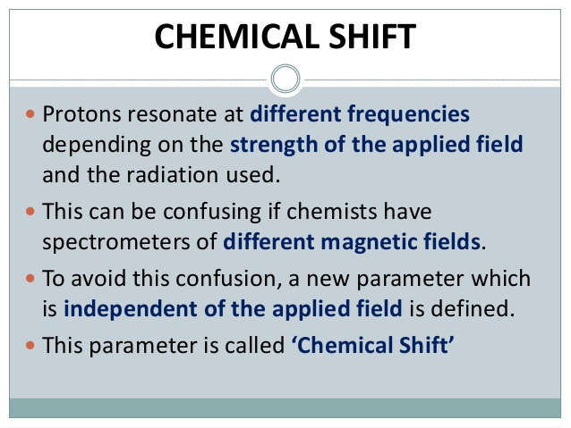

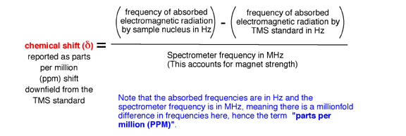

* Shift in frequency of atoms depending on their different chemical environments.

OR

* The frequency at which any nucleus will resonate in the NMR spectrum
* Characteristic positions of the peaks in NMR

OR

* The difference in the absorption of a particular proton from the absorption position of a reference proton.

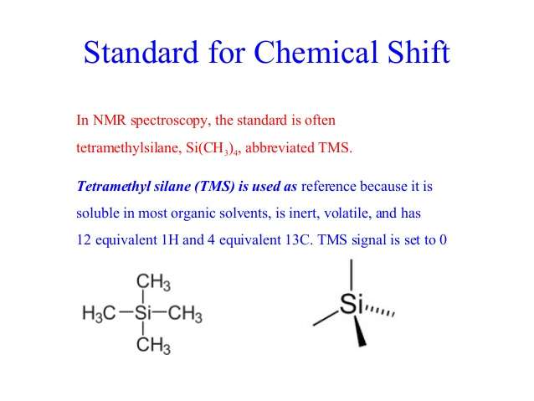

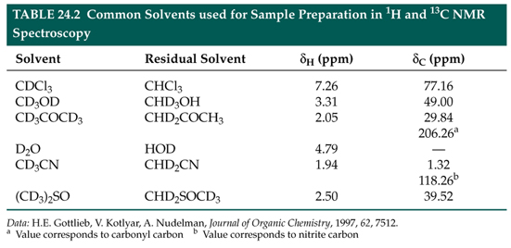

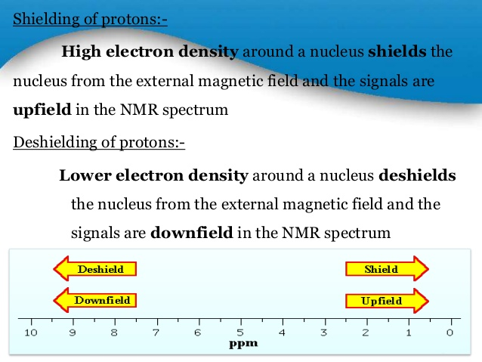

Shielding or

Diamagnetic shift

Deshielding or

Praramagnetic shift

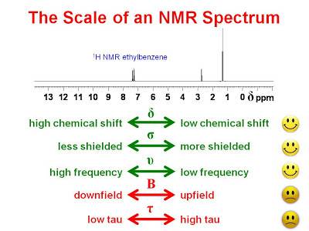

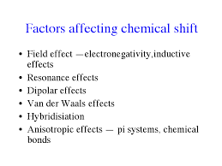

**1. Electronegativity of neighbouring groups or atoms**

e.g. C**H3**-CH3 C**H3**-Cl C**H3**–OCH3

δ 0.26 δ 3.06 δ 3.24

(shielding effects) (deshielding effects)

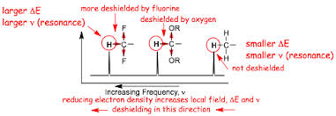

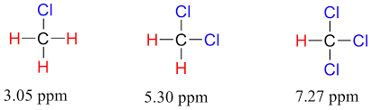

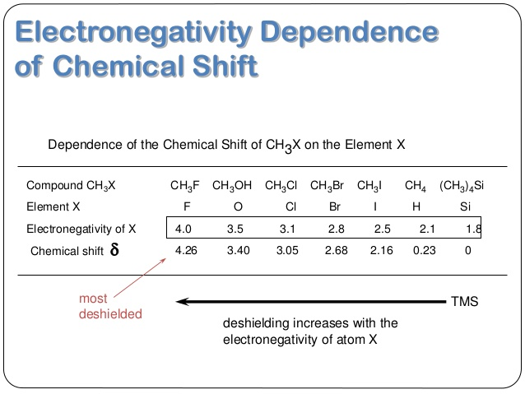

1. **Hybridization**

In general: Methine H > Methylene H > Methyl H

SP2 > SP3, e.g. C-C-H appears at δ 0.5 – 1.5 ppm

1. **Magnetic anisotropic effects**

π-electrons create non uniform fields in the vicinity of protons ⇒ for some protons the effect of these fields will be shielding while for others deshielding.

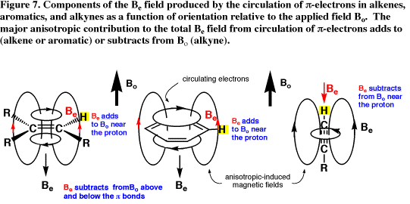

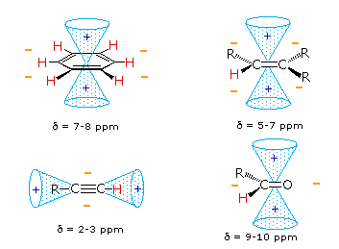

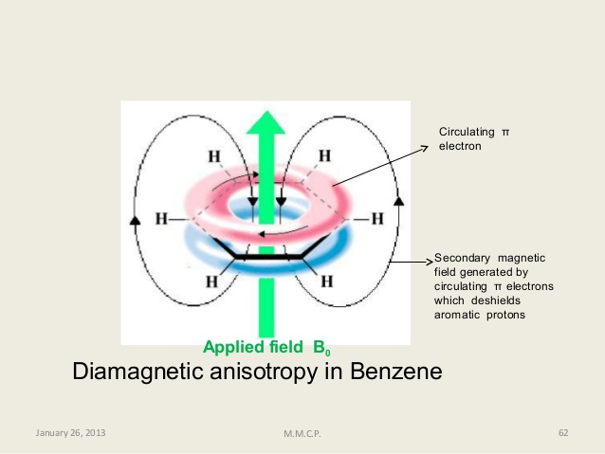

⇒ Protons around the periphery of the ring experience a magnetic field greater than Bo ⇒ come to resonance at higher δ values.

⇒ Protons above or below plane of ring resonate at low δ values.

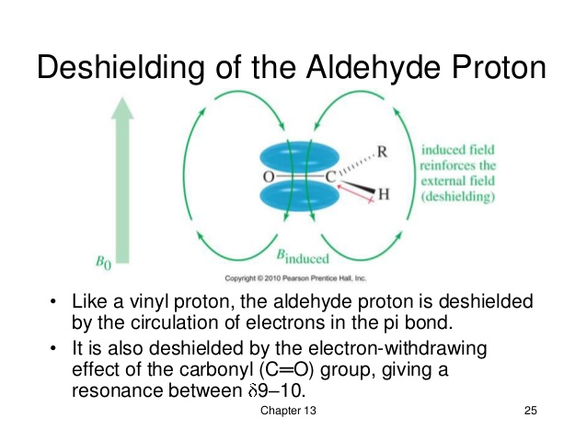

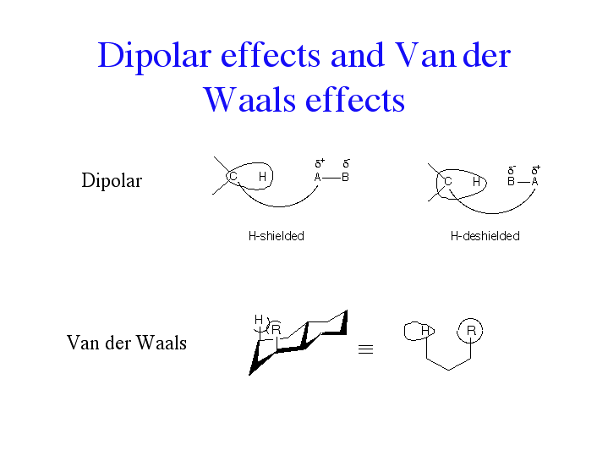

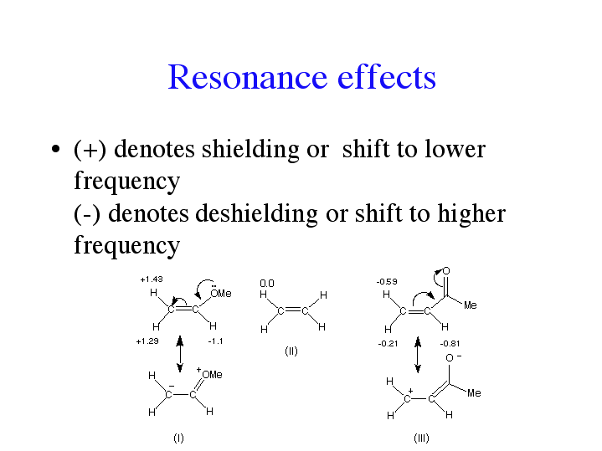

Integrals in 1H NMR

* Area under each peak signal is proportional to the number of hydrogen atoms in that environment ⇒ relative quantities of the resonance nuclei with different chemical environment.

Spin–Spin splitting (coupling)

* A magnetic “through bond” interaction between the two nuclei which are coupled ⇒ brought about by the interactions between local magnetic fields and bonding electrons.
* Related to the number of possible spin orientations that these neighbours can adopt.

1st order splitting ⇒ n + 1 rule where n = number of neighbouring protons.

**The splitting is due different magnetic environments.**

**Examples**

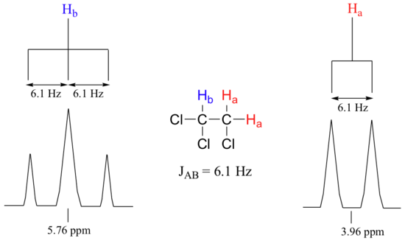

**The number of split peaks in the signal is called multiplicity.**

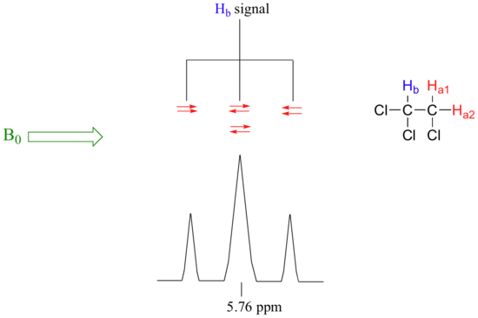

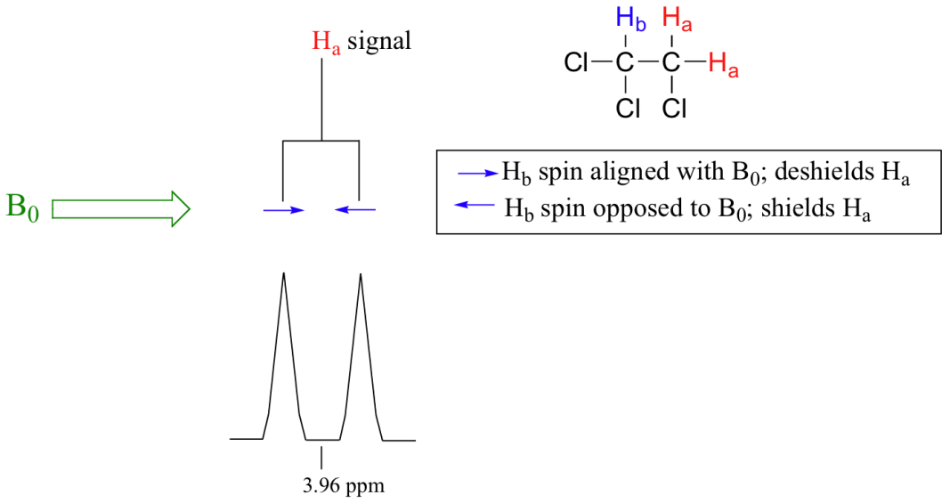

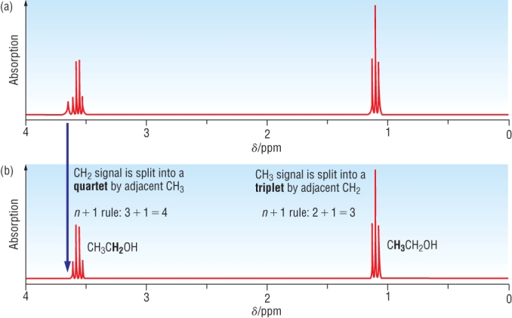

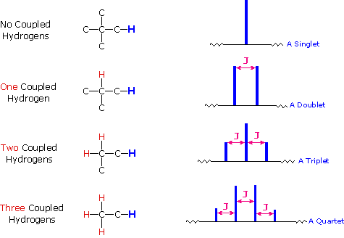

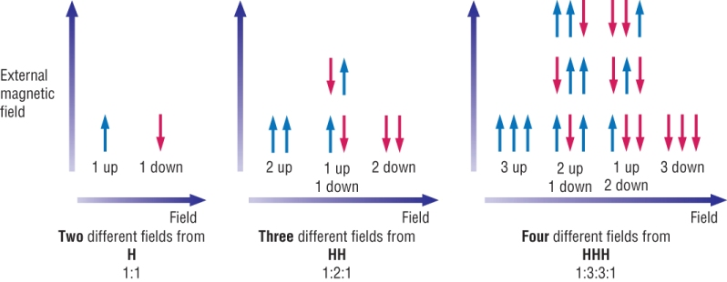

**NB:** (i) Peak splitting (coupling) generally not observed among chemically and magnetically equivalent protons.

**Two protons are defined as being magnetically equivalent if each couples equally to a third neighbouring proton (coupling equivalent).**

(ii) **Two protons are defined as being chemically equivalent if by virtue of symmetry within the molecule, their electronic environments are indistinguishable ⇒ posses same value of chemical shift (chemical shift equivalent)**

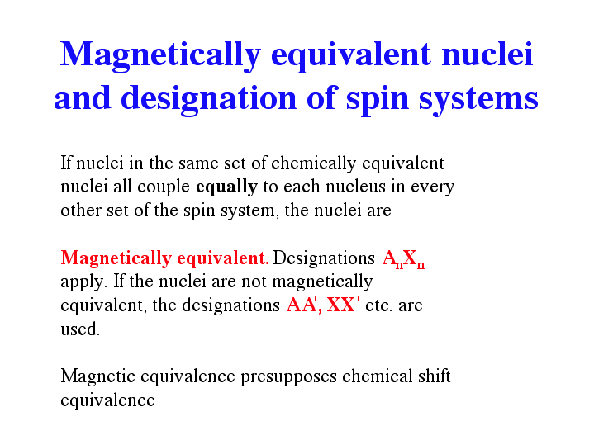

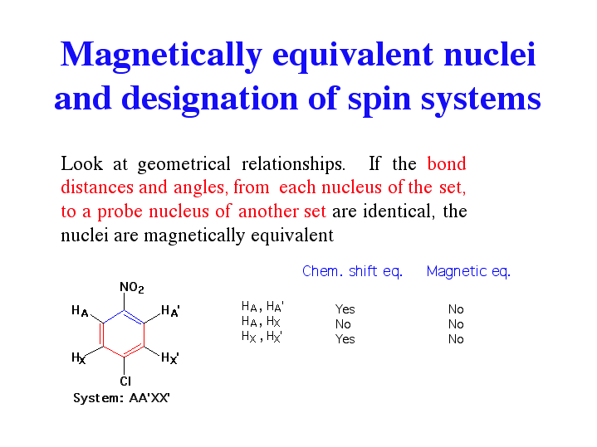

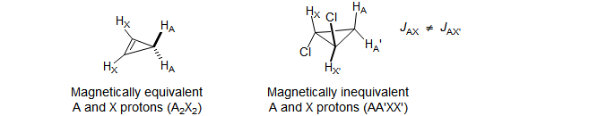

* 2 protons which are chemically non-equivalent must also be magnetically non-

equivalent but 2 protons can be magnetically non-equivalent but chemically equivalent.

* Normally coupling upto 3 bonds (3J)

**Successive splitting ⇒ use of scale diagram**

* Interacting nuclei represented by the letters of the alphabet ⇒ gap between the letters indicating the separation between the nuclei in chemical shift.

Pascal’s triangle or Binomial Coefficients

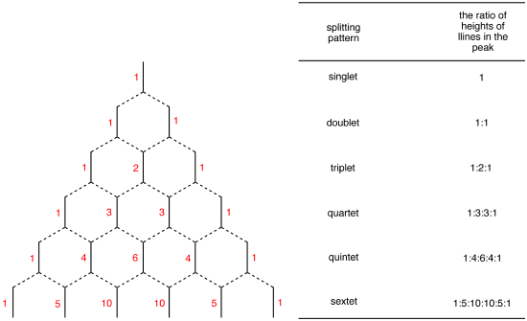

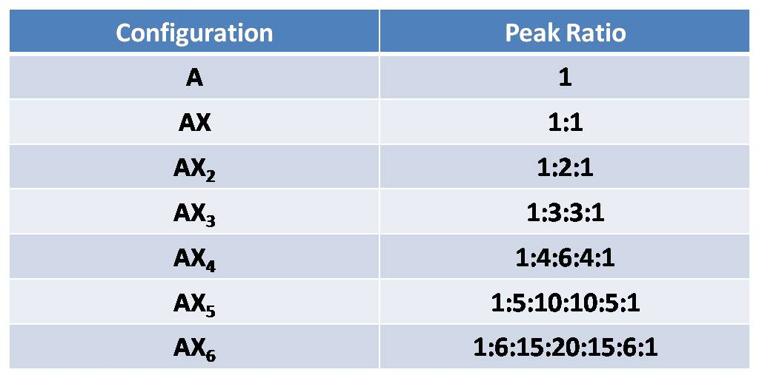

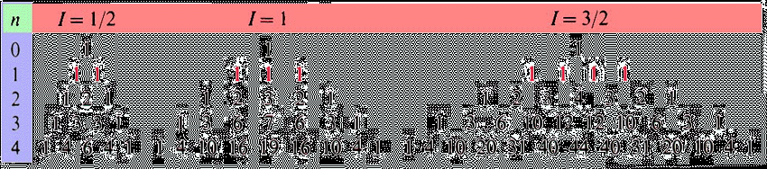

AX and AB spin system

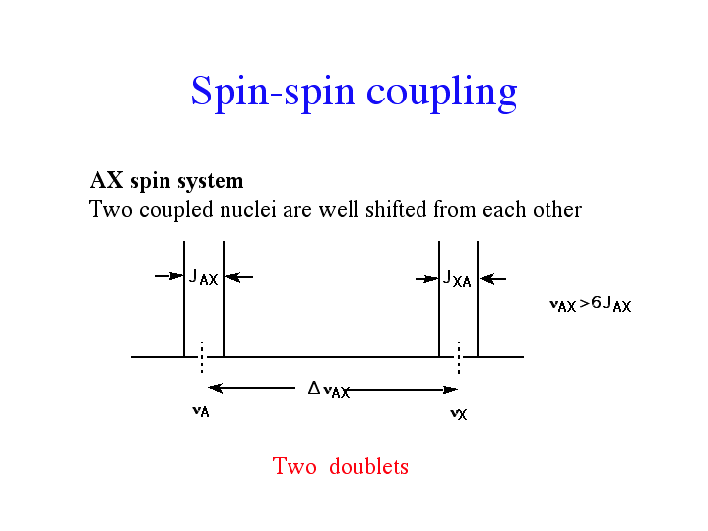

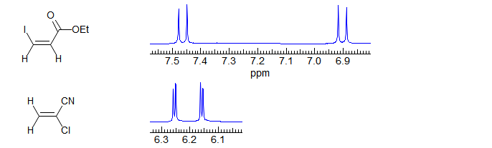

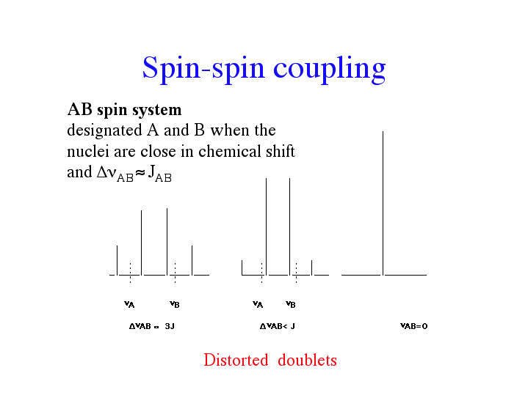

AX3 Spin system

E.g. CH3-CH

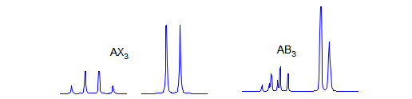

A2X2 Spin system

E.g.

Y-CH2-CH2-Z

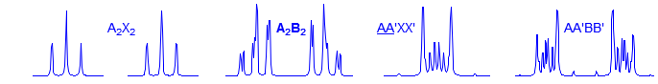

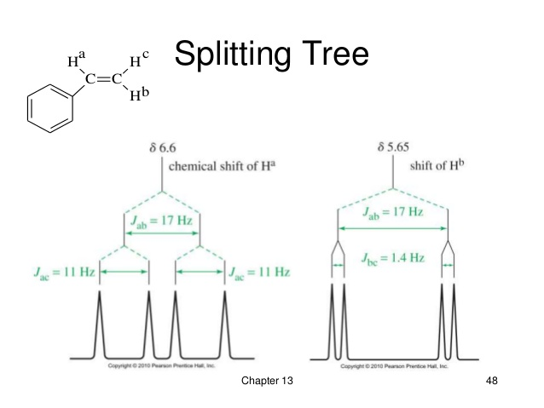

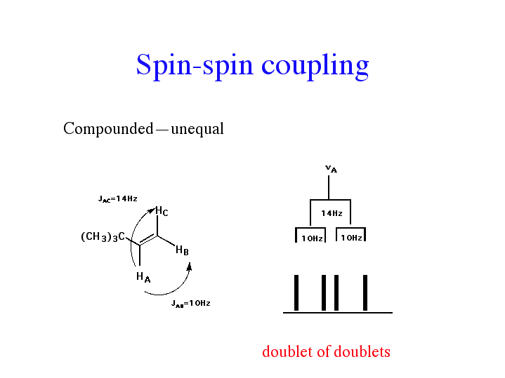

A2X3 e.g. CH3CH2Cl

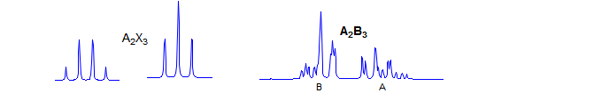

AMX

E.g.



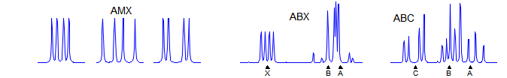

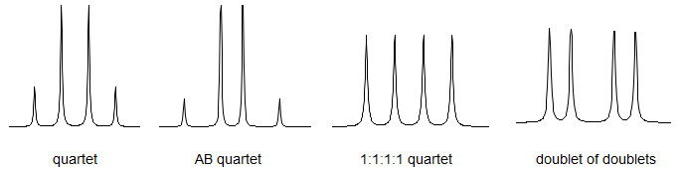

Non – first order AB splitting pattern

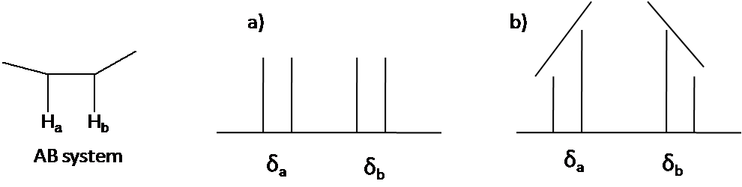

(a) First order AX (b) AB quartet

Leaning:



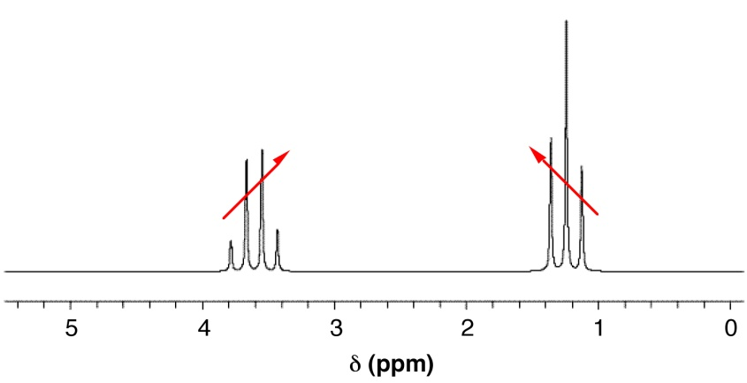

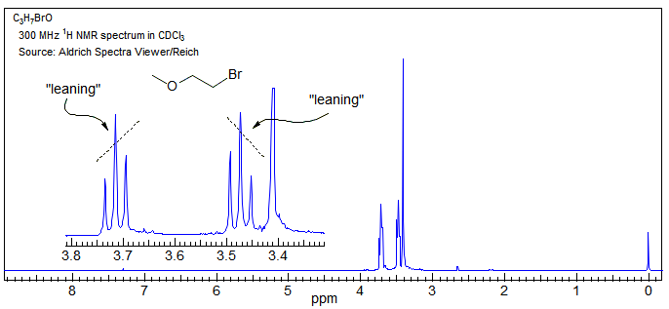

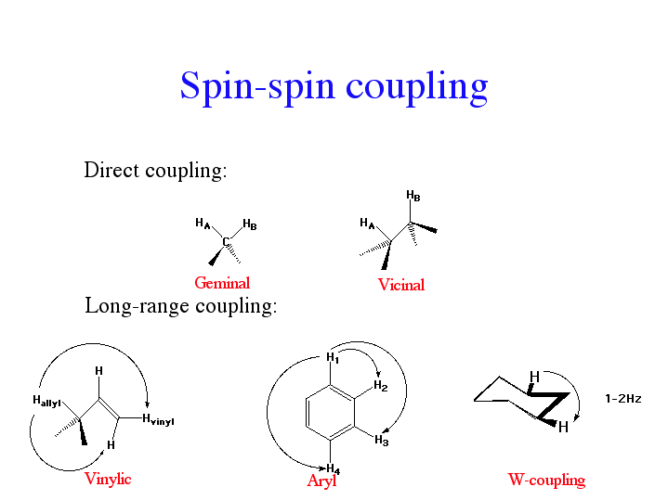

The AB Spin System and Higher Order Spin Systems

AB spin systems show coupling between two nuclei of similar chemical shift and show a variable intensity pattern that depends on the relative magnitude of the shift difference (in Hz) a - b and the coupling constant J(A,B).

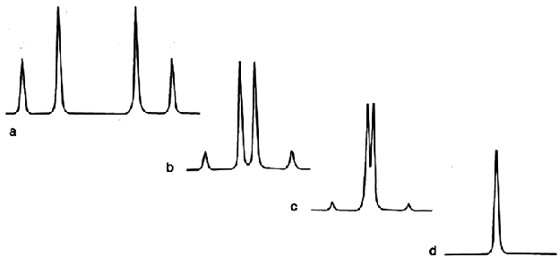

**a)** J / a - b) = 1: 3;

**b)** J / a - b) = 1: 1;

**c)** J / a - b) = 5: 3;

**d)** J / a - b) = 5: 1

Spectra a) to d) which show deviations from the binomial intensity pattern are called higher order spectra.

**Coupling Constants**

* The difference between the peaks arising from a coupling interaction between neighbouring protons with different chemical shifts.
* Expressed in Hertz (Hz)
* Independent on the magnitude of the applied field.
* JH-H
* Characteristic of the type of protons causing the splitting
* High field NMR spectrometers are very useful since stronger fields do not affect J but influence ν.
* Spectra run in high fields are more likely to be first order, because the ratio $∆/J$ is larger.
* 1st order if δA – δB (Hz) ≥ 10JAB (Hz)

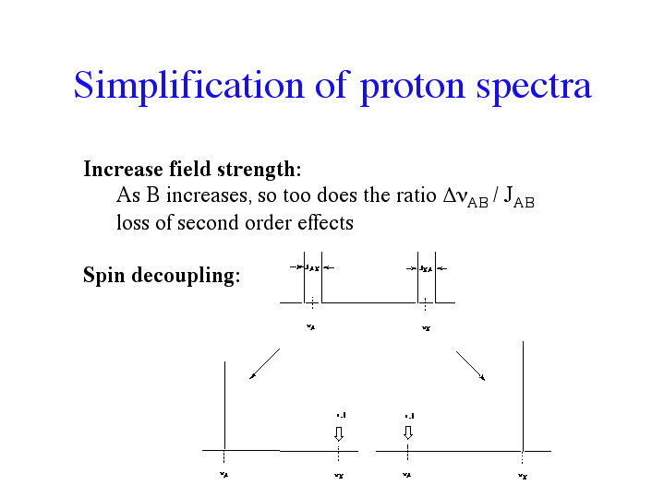

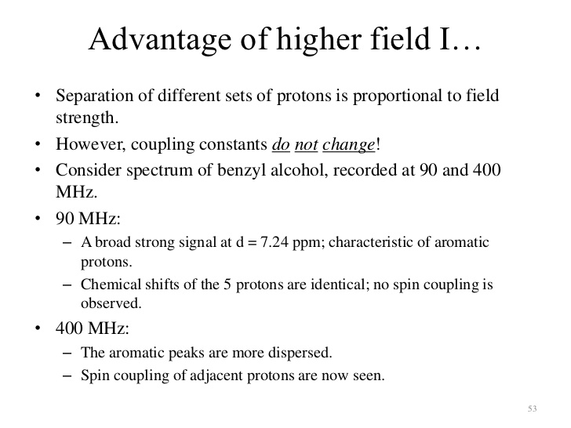

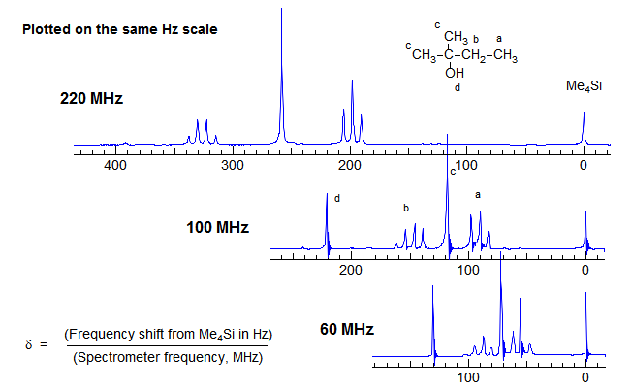

 The effects of spectrometer field strength on the ability to resolve NMR coupling information is illustrated in this set of spectra of ethylbenzene, plotted at a constant Hz scale. The aromatic signals go from nearly a singlet at 60 MHz to a reasonably resolved set of peaks at 600 MHz (spectra courtesy of Kris Kolonko). This increase in information content and greater ease of interpretation of NMR spectra at higher magentic field strength is the main justification for the additional expense of more powerful magnets.

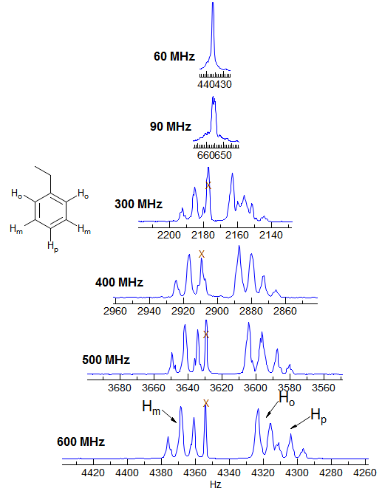

**Factors affecting J values**

1. **Number of bonds between the coupling nuclei**

E.g 1JCH ≈ 120 – 250 Hz

2JHH ≈ 10 – 20 Hz (aliphatic germinal)

3JHH ≈ 5 – 8 Hz

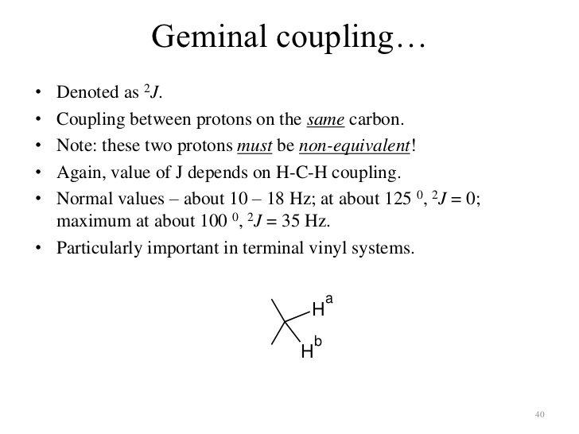

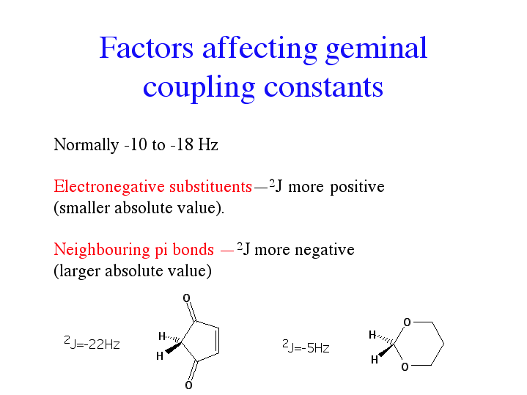

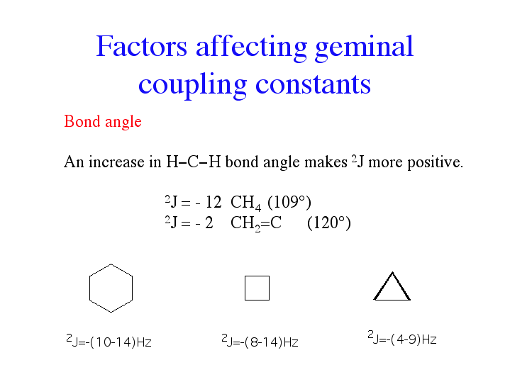

1. **Molecular environment of the nuclei**

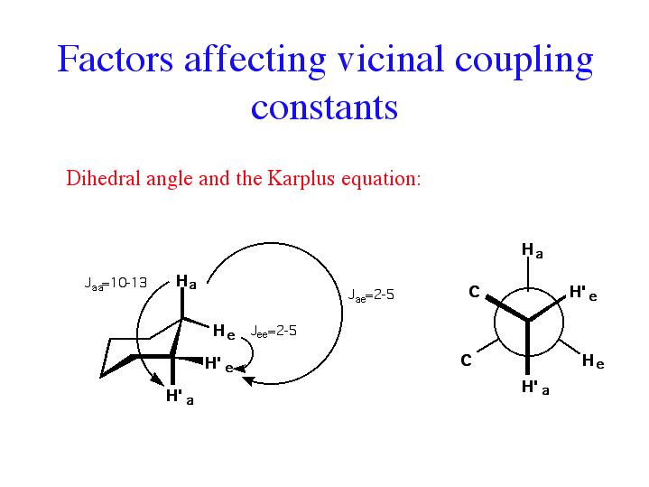

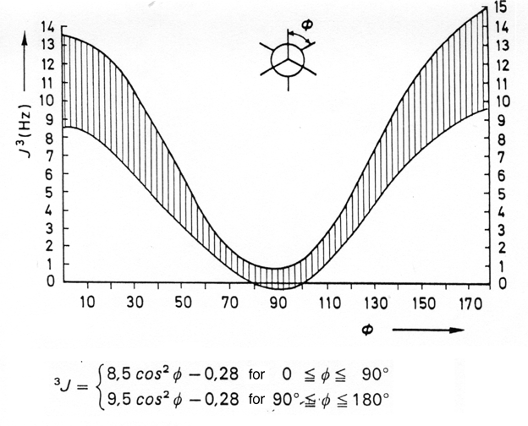

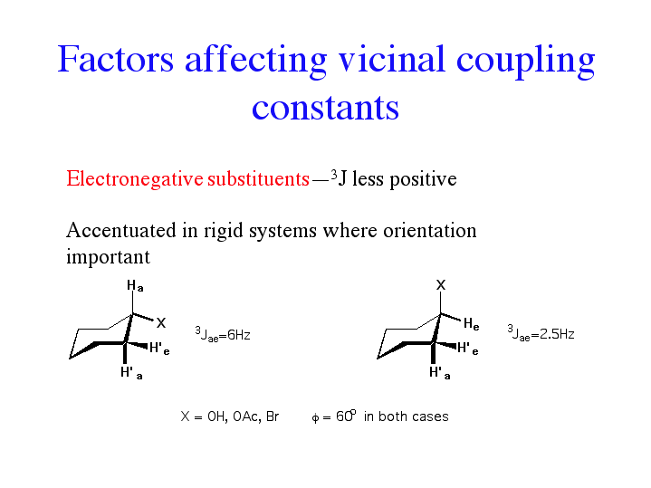

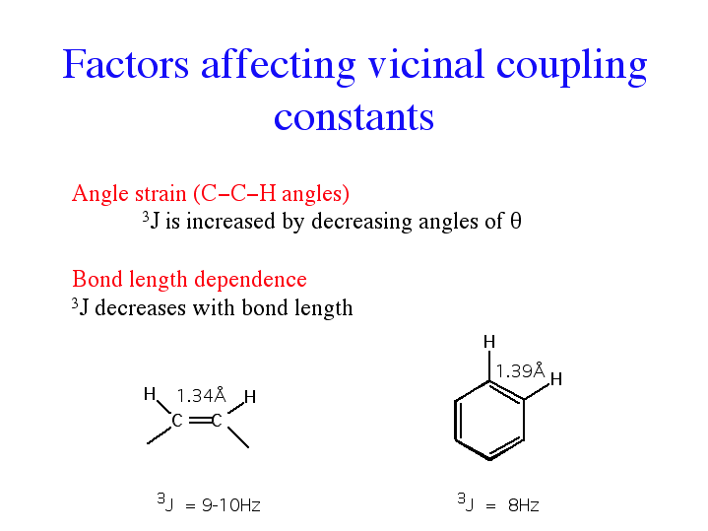



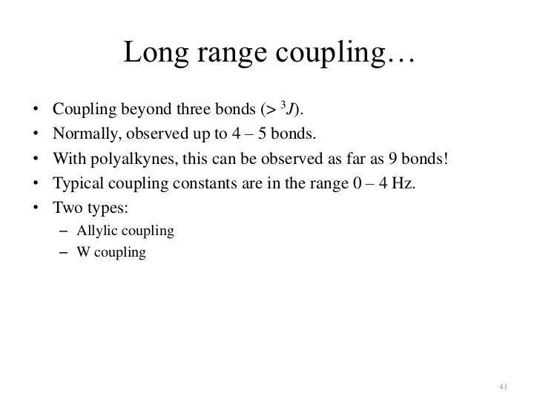

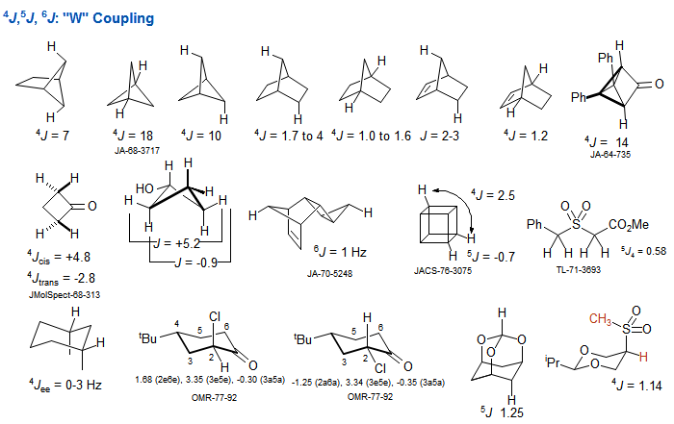

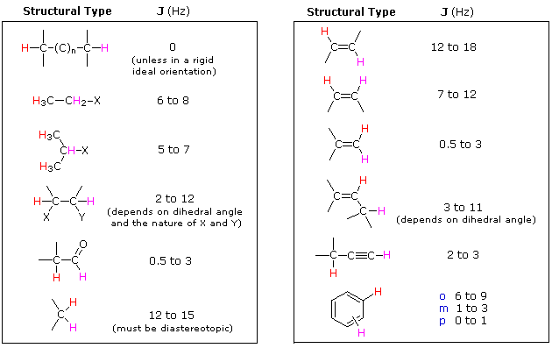

* Presence of electronegative elements directly attached to the same carbon atom as one of the vicinally coupled protons decreases the magnitude of the coupling constant.
* electropositive elements increase it.

⇒ more pronounce in rigid systems e.g. alkenes

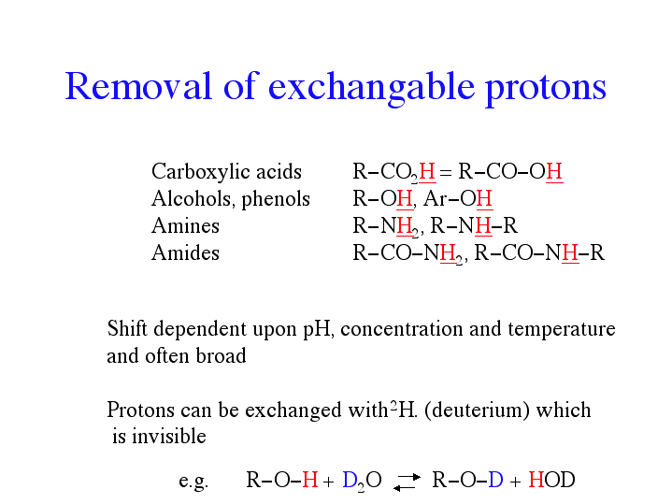

RCOOH becomes ROOD; ROH becomes ROD and RCONH2 becomes RCOND2 etc.

**Decoupled, NOE (Double Resonance) and COSY Spectra**

* If it is not obvious which protons in a molecule are coupled to which ⇒ can determine coupled signals through the use of decoupling experiments.
* Irradiate one nucleus while detecting all the other nuclei in the molecule i.e. “double resonance” using two pulses of radiation ⇒ signal due to any nucleus coupled to that being irradiated increases in intensity.

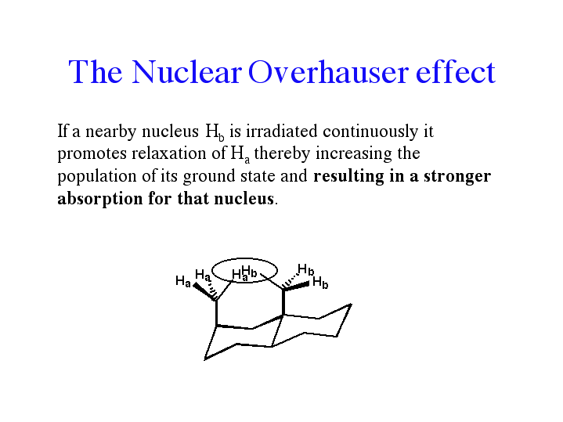

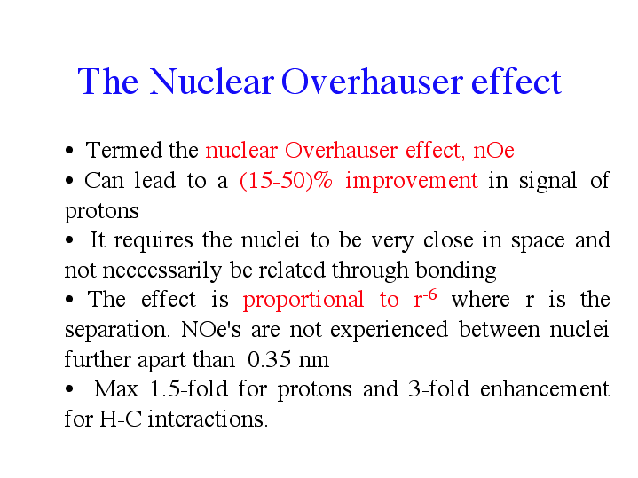

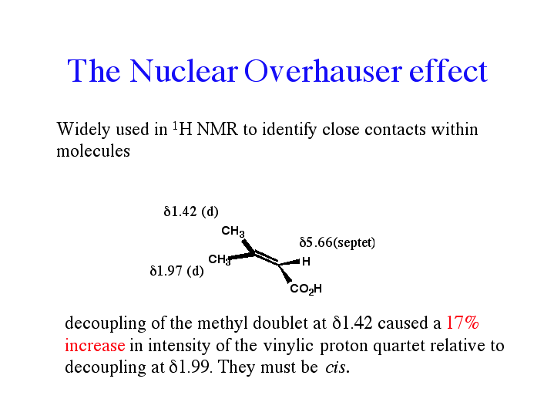

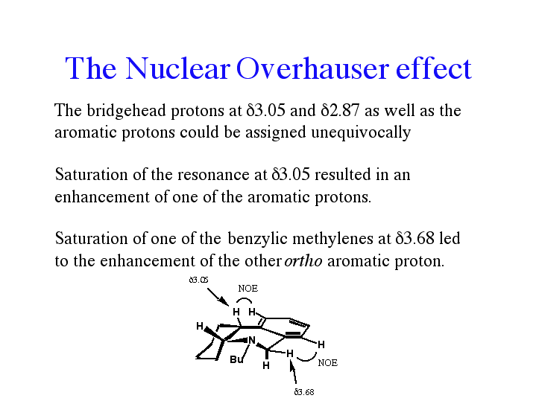

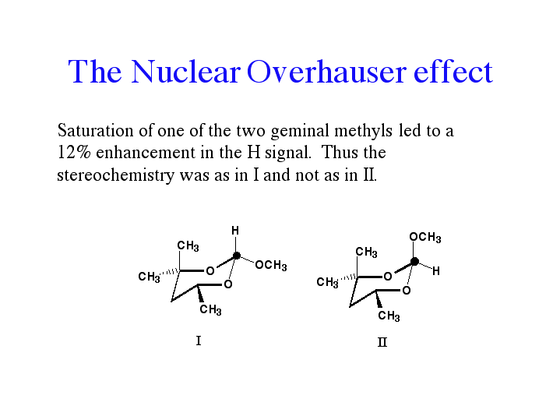

This technique not used very much ⇒ COSY now being used.

**COSY Spectra**

COSY ⇒ **CO**rrelated **S**pectroscop**Y**

* used to determine all of the coupling interactions in a single experiment.
* involves a multiple pulse sequence and is an example of two–dimensional (2D)

spectroscopy.

1H1H COSY ⇒ helps to correlate the 1H shifts of all the coupling partners in the molecule.

* “normal” 1H spectrum plotted on both the X– and Y–axes and a projection along the diagonal (with the peak heights represented by contours).
* Off the diagonal peaks (or cross peaks) are the key signals.
* Cross peaks appear on either side of the diagonal axis and are symmetrical about it.
* A particularly popular 2D NMR experiment is the COSY experiment.
* COSY experiments are often 1H-1H experiments but there are many other correlations in the literature.
* The COSY transfer , which proceeds through J-coupling relies on quantum mechanical effects and cannot be explained with classical models. By applying a single (p/2)x rf- mixing pulse, it is possible to transfer coherence of spin **a** into coherence of spin **b** where these spins couple. Only with coupling do off-diagonal peaks occur. Consequently, COSY spectra are a terrific way to establish connectivity of networks.

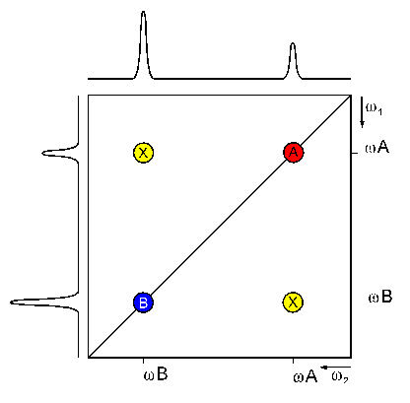

* The (H,H) COSY experiment establishes the connectivity of a molecule by giving cross peaks (these are the off diagnonal peaks) for pairs of protons that are in close proximity. For the example of Glutamic acid below, we obtain cross peaks for the proton pairs (2,3) and (3,4). We do not observe a cross peak for the pair (2,4) ⇒ because these protons are not directly adjacent.

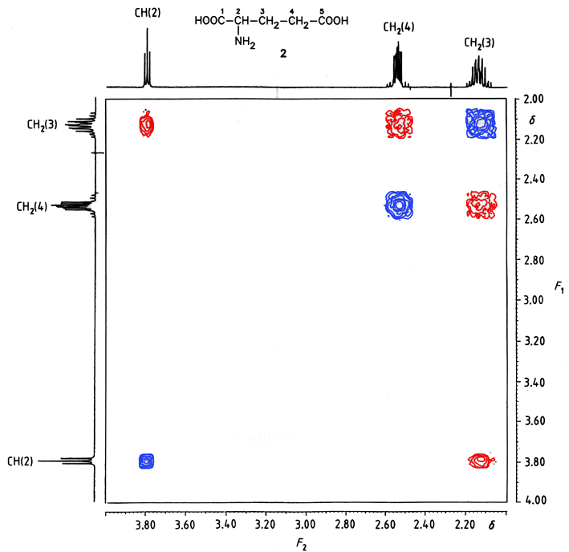

*500 MHz (H,H) COSY Spectrum of Glutamic acid. 1-D spectra left and top. 10 mg of compound in 0.5 mL of D2O, 5 mm sample tube, 256 spectra, digital resolution of 2.639 Hz/data point. Total measurement time ca. 3h.*

A **relayed COSY** experiment goes one step beyond a COSY experiment by showing cross peaks not just for pairs of adjacent protons, but for triples as well. As a result, we observe additional cross peaks like the one for the pair 2,4 in Glutamic acid below. Relayed COSY experiments can give cross peaks for protons that are too distant to show coupling in the 1D NMR spectrum.

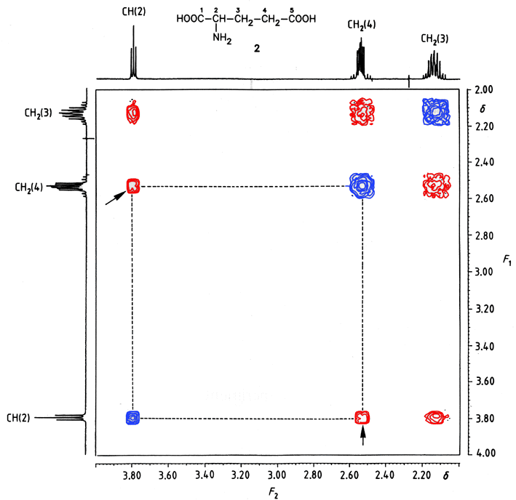

With present hardware and pulse sequences, it is possible to repeat the relay step up to three times. This allows the correlation of of protons that are separated by up to six bonds. The relaying nucleus is typically 1H, but high abundance I =1/2 hetero-elements like 31P or 19F can be used as well.

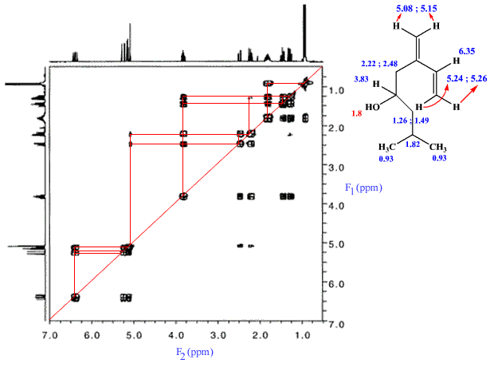

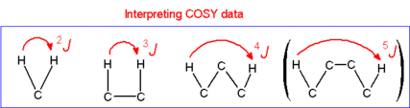

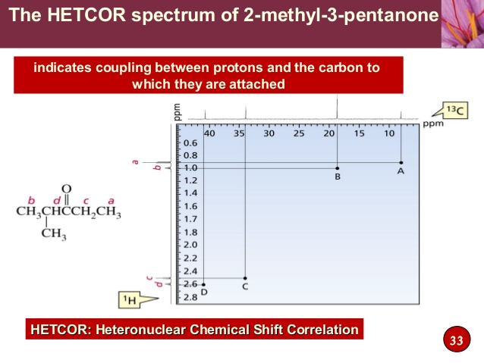

NOE Spectra

NOE ⇒ Nuclear Overhauser Effect

2D-NOE Techniques

Irradiate one nucleus with a low – level radiofrequency signal (double resonance) and monitor what is happening in the rest of the spectrum ⇒ enhancement of the signals for nearby nuclei is observed.

* through–space interactions
* Helps to get which protons are close in space to each other in a molecule
* Used to study conformation e.g. proteins.
* 2D version which gives all the NOE effects in the molecule in a single spectrum ⇒ NOESY.

NOE techniques complement techniques that involve scalar coupling because they establish the proximity of non-bonded atoms. Most published data are on 1H,1H experiments. Common pulse sequences:

* NOESY (3-dimensional structure of molecules, exchange processes)
* zz-NOESY (solvent peak suppression, differentiation between chemical exchange and NOE).

**NOESY & HOESY**

The cross peaks in NOESY are due to pairs of nuclei that are close enough (<2.5 Å) to have strong dipolar interactions. Moreover, the size of 1H-1H NOESY cross peaks is proportional to their distance. This is particularly valuable for the structure elucidation of proteins.

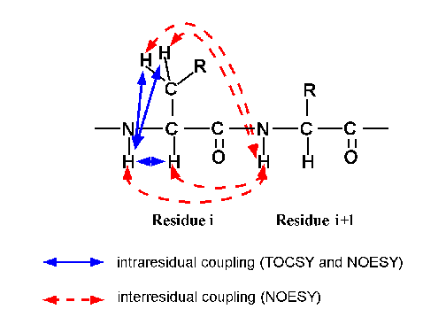

Heteronuclear NOESY experiments are sometimes called HOESY experiments.

**The Schoolery Rule**

* ­Help to predict the chemical shifts of various organic molecules

**Examples:**







**13C NMR Spectroscopy**

12C ⇒ abundances 98.9% ⇒ but nuclear spin (I) of O.

13C ⇒ 1.1% ⇒ nuclear spin (I) of ½

* Carbon skeleton
* Generally less signal overlapping (simpler)
* Spread over a wider range O – 220 ppm; compare with 1H NMR ⇒ 0 - < 20 ppm
* Low abundance of 13C gives low probability of 2 adjacent carbon atoms having 13C ⇒ no 13C – 13C coupling but have 13C – 1H coupling ⇒ follows n + 1 rule where n = no. of H atoms.
* Chemically and magnetically equivalent C atoms appear together on the spectrum.
* Area under each peak not always proportional to the number 13C nuclei giving rise to it ⇒ NO integration of peaks.
* Data harder to obtain then 1H ⇒ use more scans and more sample.

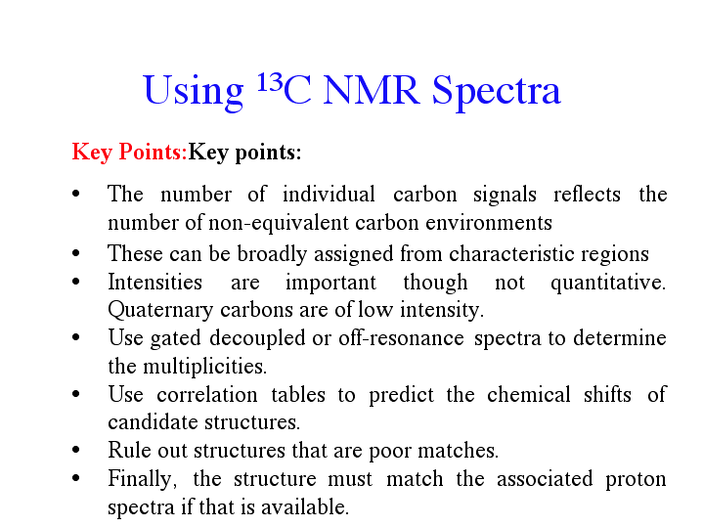

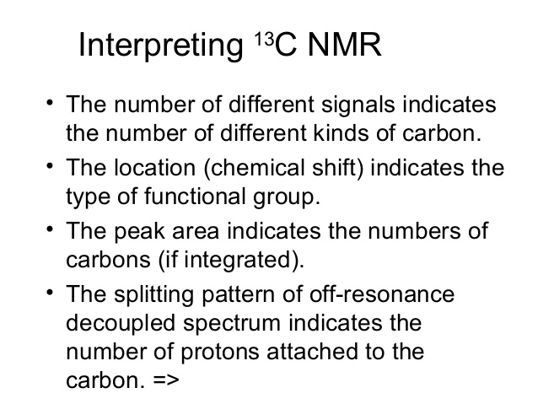

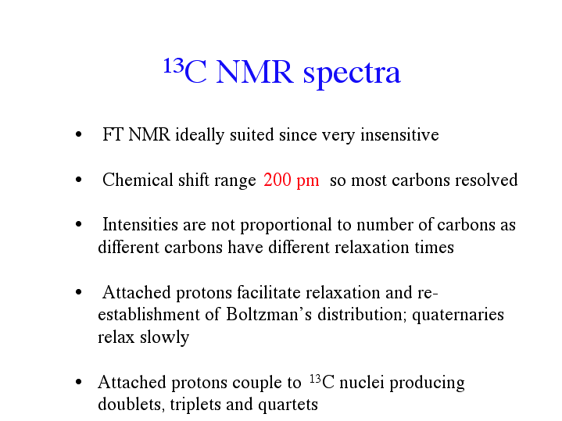

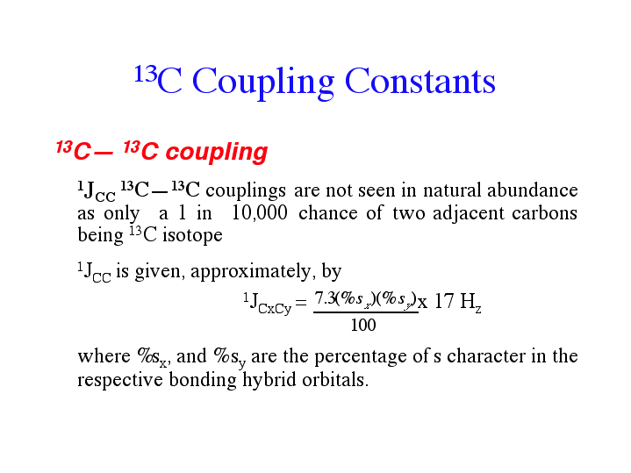

⇒ Conventional 13C spectrum referred to as being proton decoupled and consists of a plot of

chemical shift against intensity.

⇒ Irradiate the H over the entire proton frequency range while obtaining the carbon spectrum (**broad-band decoupled spectrum**).

⇒ Irradiation enhances the signal–to–noise ratio by as much as 300% (NOE)

⇒ Coupling of 13C – 1H cause complex spectrum ⇒ thus partial decoupling of 13C – 1H signals produces **off–resonance spectrum** ⇒ only 1JCH is seen.

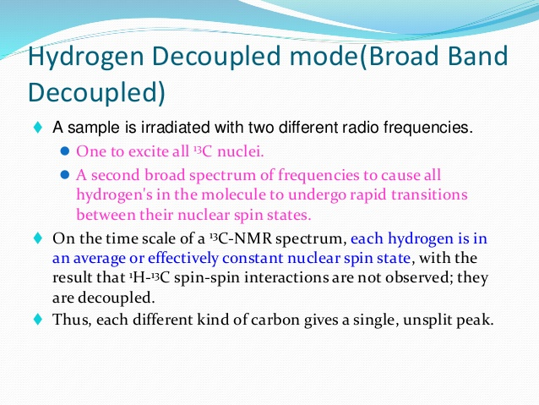

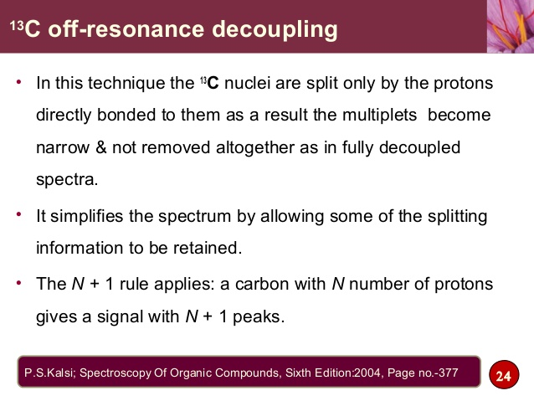

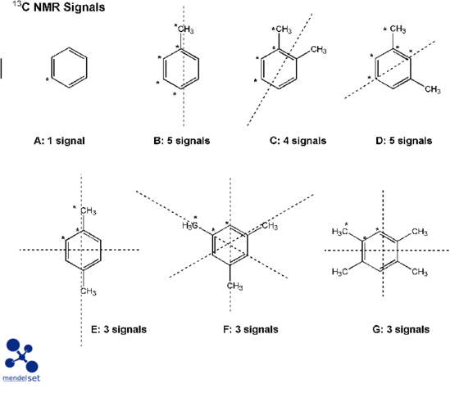

Alkanes: ≈ δ 10 – 30 ppm



* The greater the substitution of the carbon atom, the more deshielded.
* Electron withdrawing atom or groups ⇒ results in a deshielding effect ⇒ higher δ value.

Alkenes: ≈ δ 100 – 140 ppm

Alkynes: ≈ δ 75 – 105 ppm

* Depends on the substituents present on the multiple bonds.

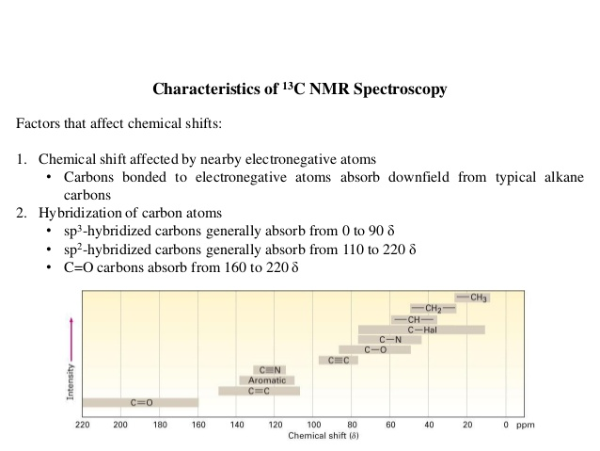

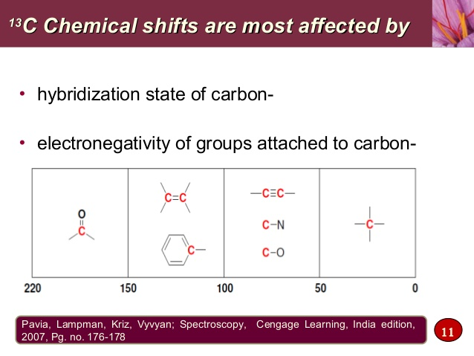

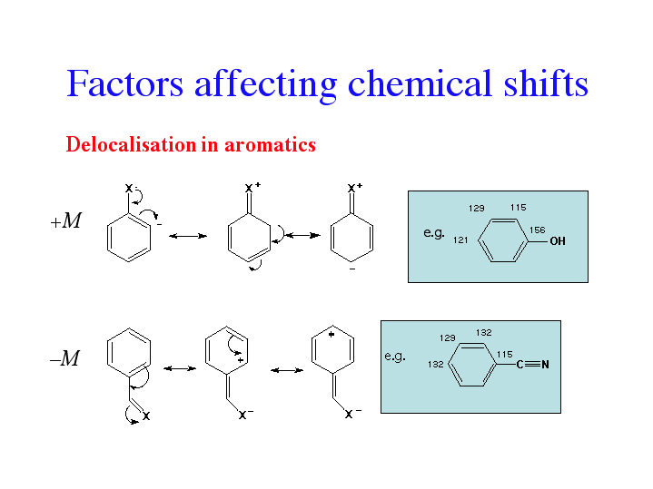

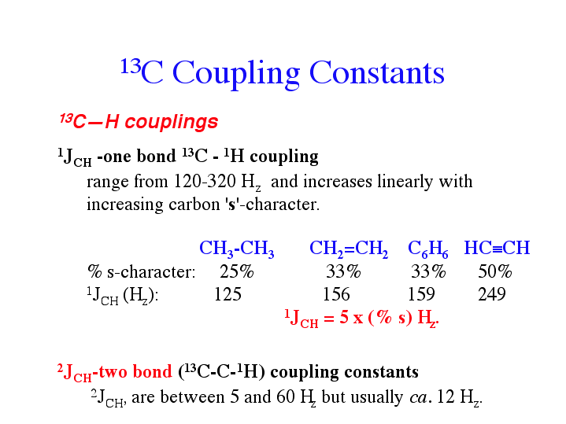

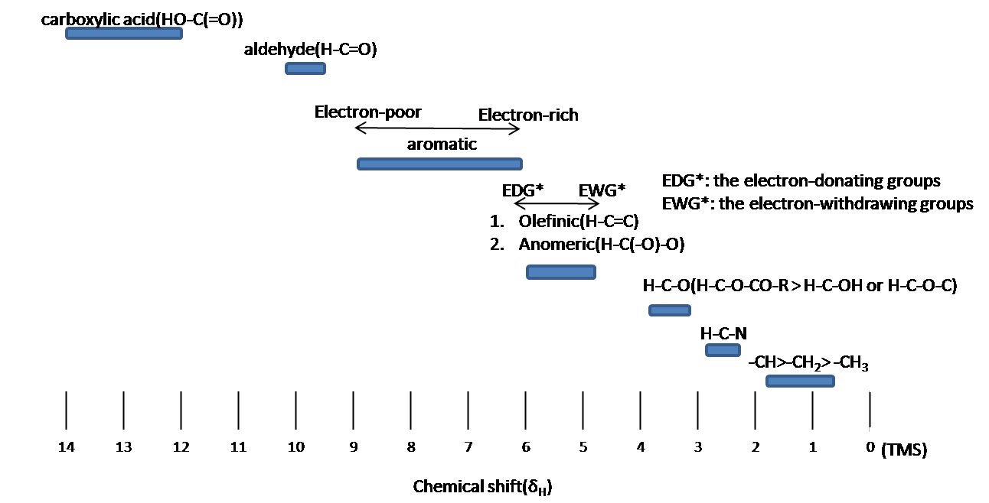

Aromatic 13C chemical shifts

δC = 128 + ΣΔX where X = substituents

**Example:**



|  |  |  |  |  |  |  |
| --- | --- | --- | --- | --- | --- | --- |
| Carbon | Base | OH | COR | δtotal | δobs | intensity |
| 1 | 128 | -7 | +9 | 130 | 129 | low |
| 2/6 | 128 | +1 | +1 | 130 | 131 | high |
| 3/5 | 128 | -13 | +1 | 116 | 116 | high |
| 4 | 128 | +27 | +6 | 161 | 161 | low |

Assignment Techniques which can be run to aid interpretation and assignment of difficult 13C NMR spectra are:

* + 1. **DEPT**

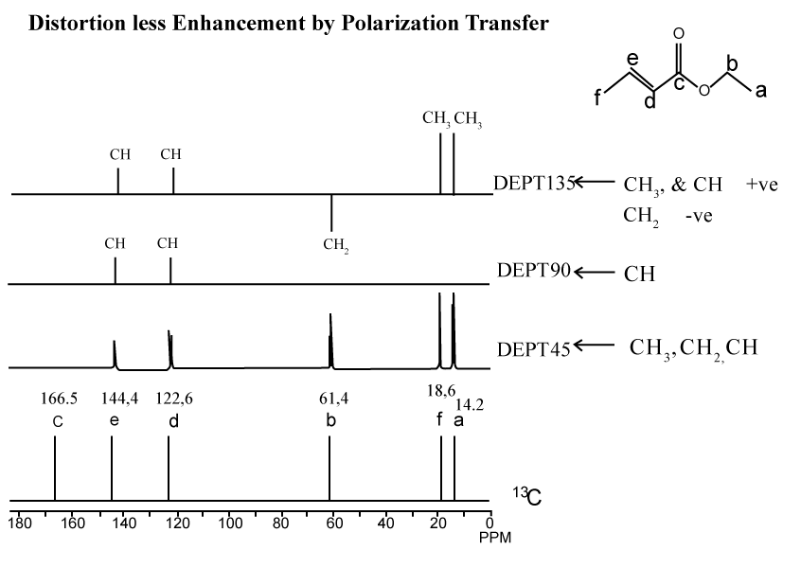

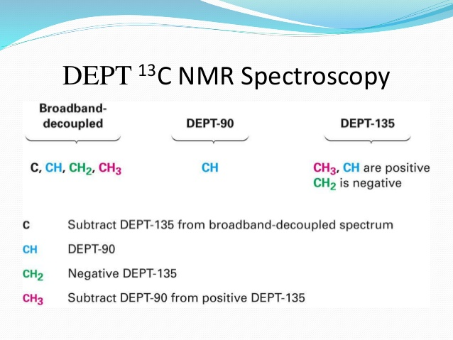

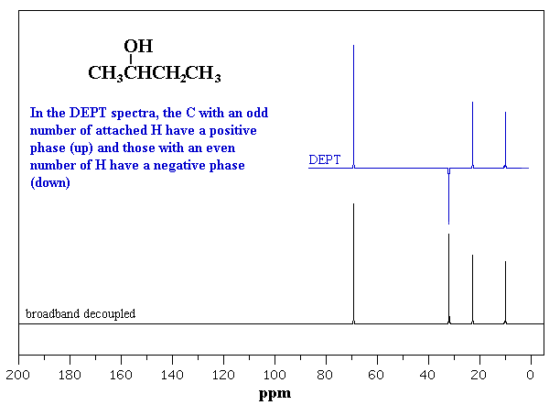

1. **Heteronuclear Multiple Quantum Correlation (HMQC)**

* 2D spectrum that shows correlation between a carbon atom and the attached proton(s) i.e. show 1JCH coupling.

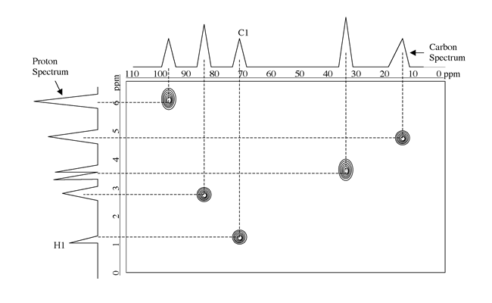

1. **Heteronuclear Multiple Bond Correlation (HMBC)**

⇒ defects longer range 1H – 13C coupling and coverts it into a correlation map

⇒ 2D

⇒ shows the connectivities of carbon atoms through their 2JCH and 3JCH coupling.

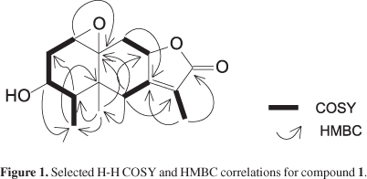

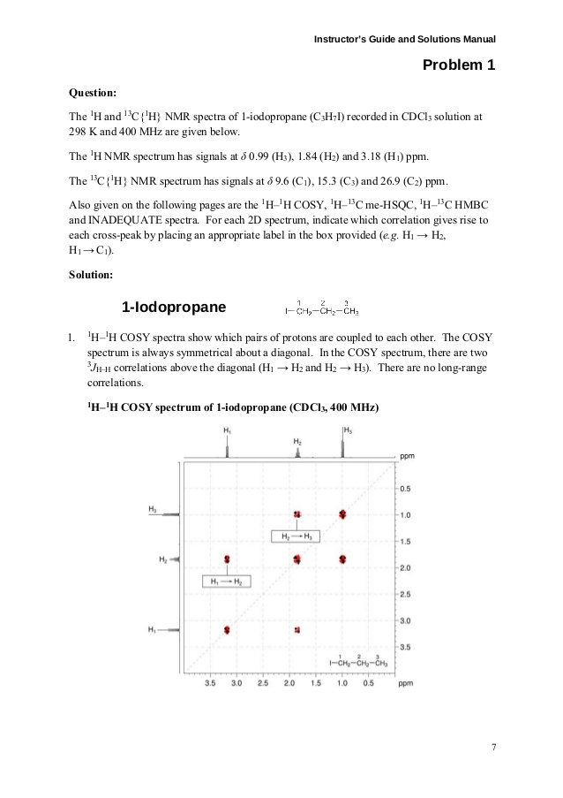

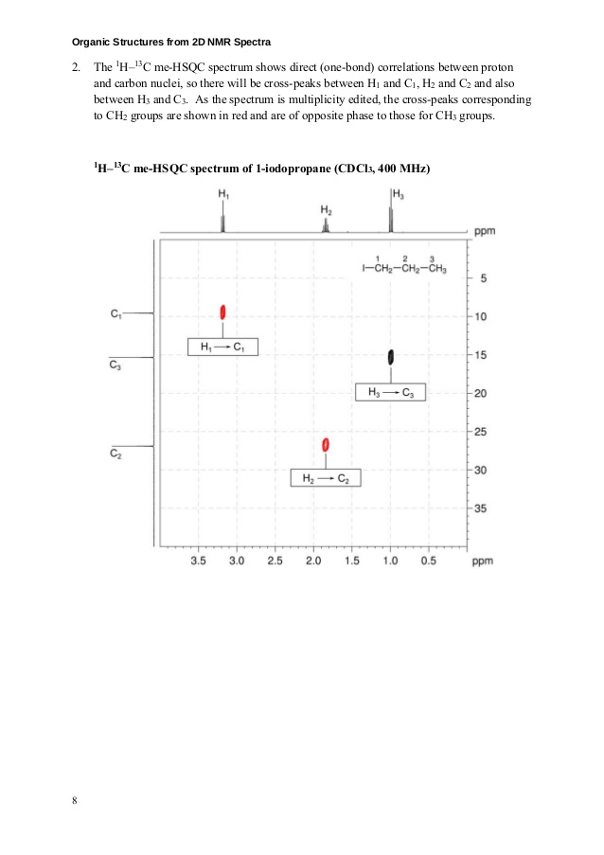

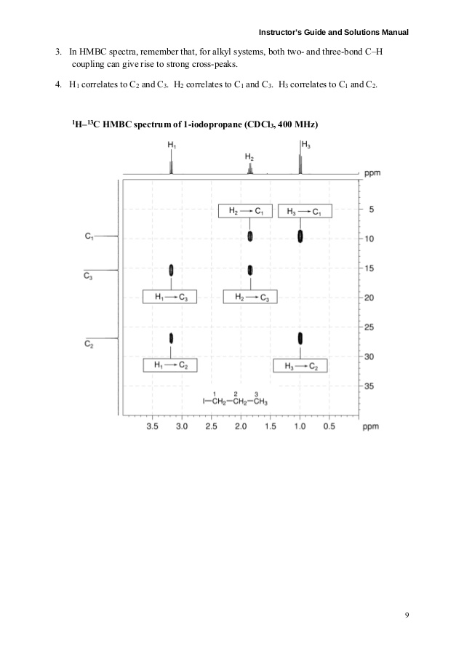

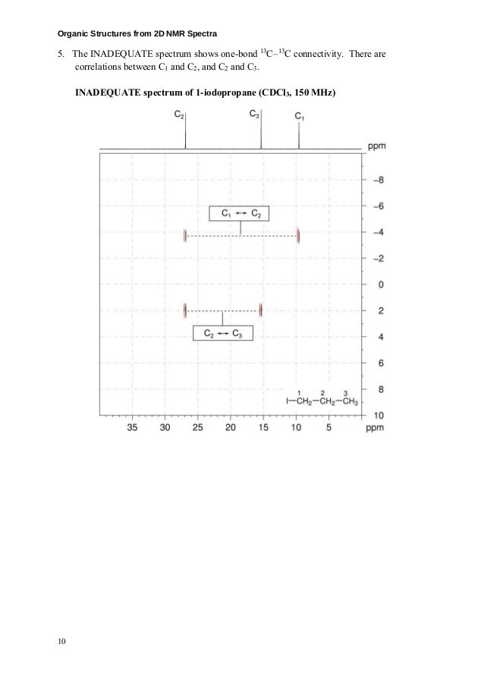

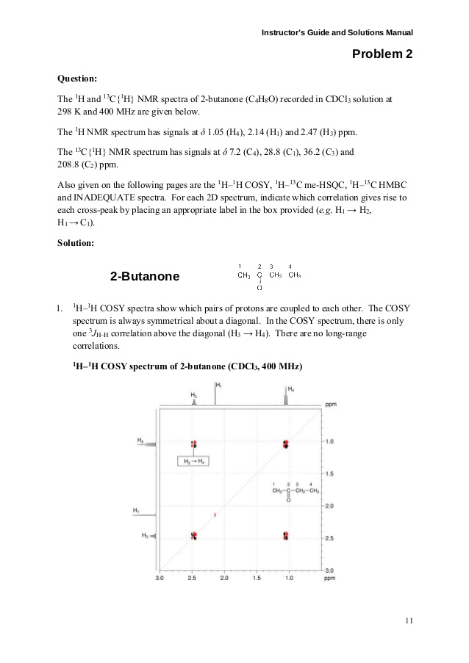

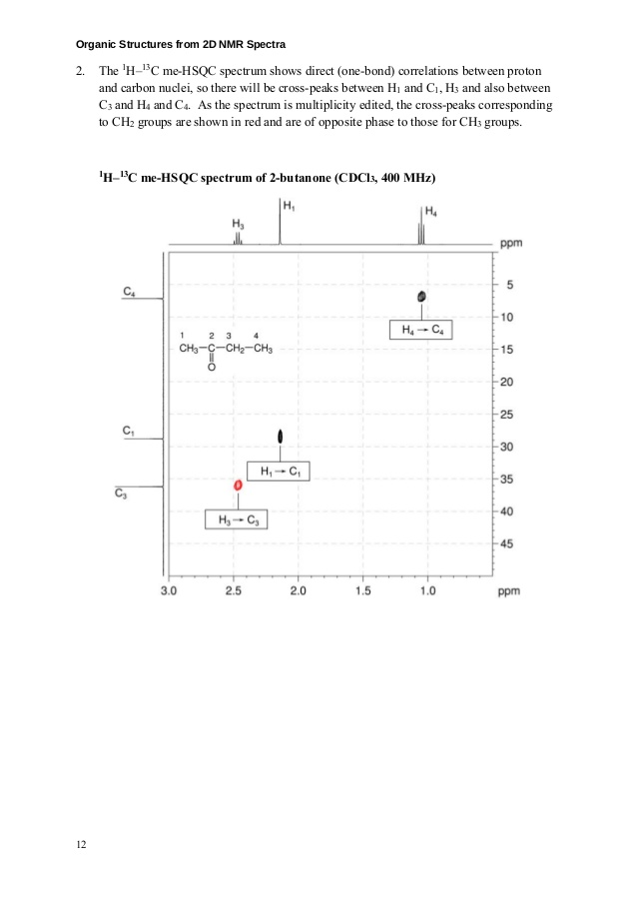

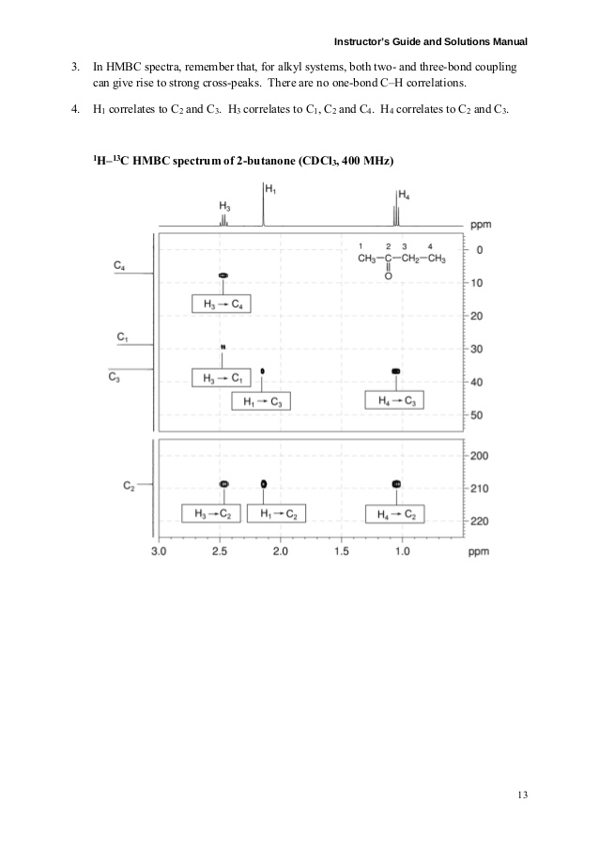

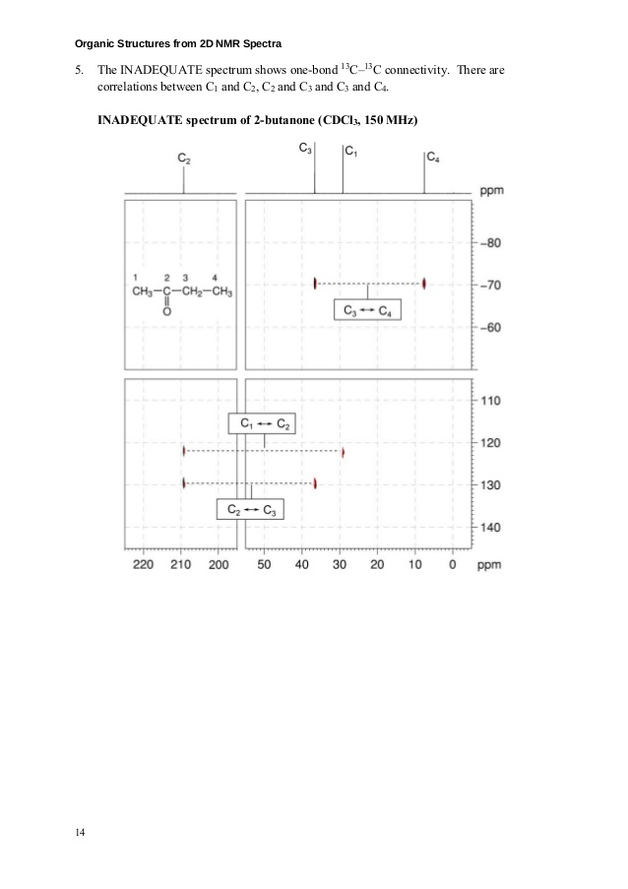

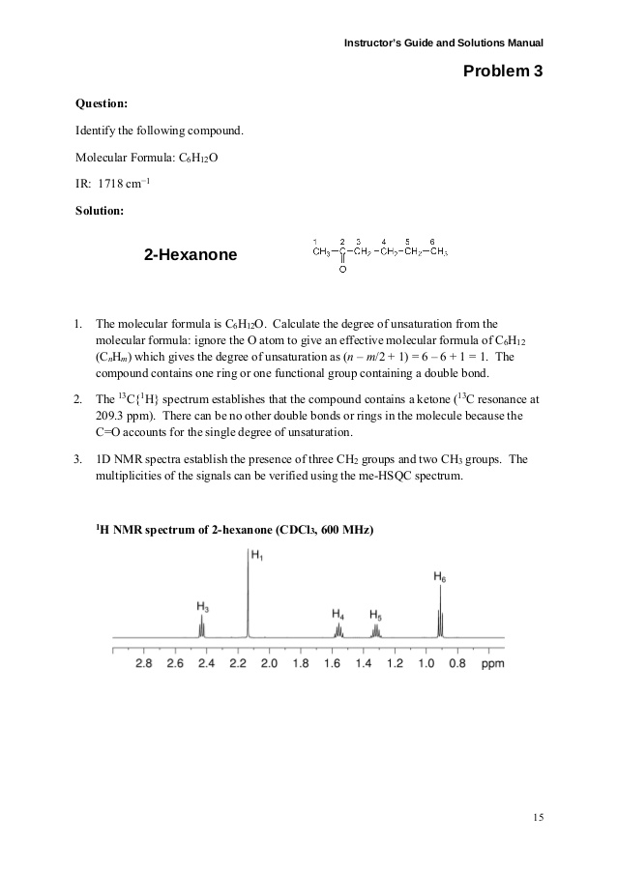

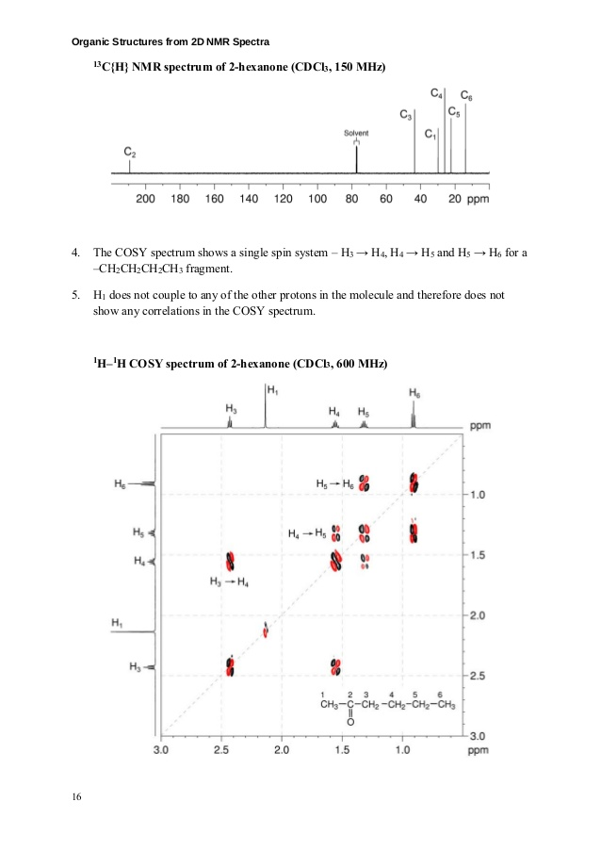

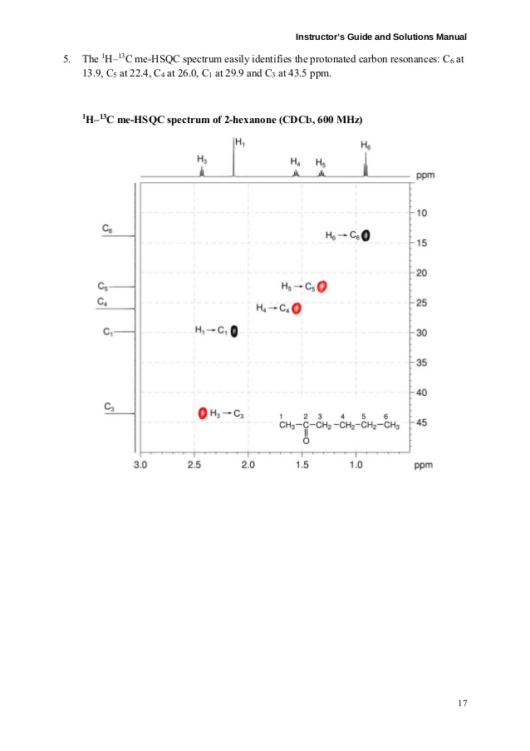

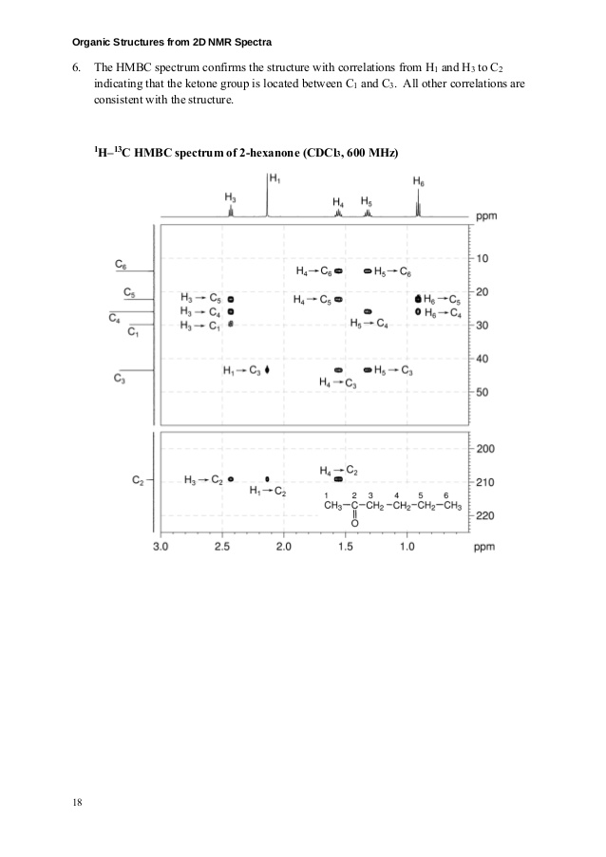**Mass Spectrometry**

* Gas phase
* Low pressure
* Bombardment of sample with electron beam and quantitatively recording the results as spectrum of +νe ions.

1. Used to measure the mass of organic molecules

⇒ help in identifying an unknown or to characterize a particular molecule

1. Used to generate information about the structure of a molecule.

Identifying analytes by Fragmentation pattern

comparison of their mass used to deduce recognizable

spectra with the spectra groupings within the

of known compounds molecule

Sample vaporized ionized

magnet Sorted by m/z

detected

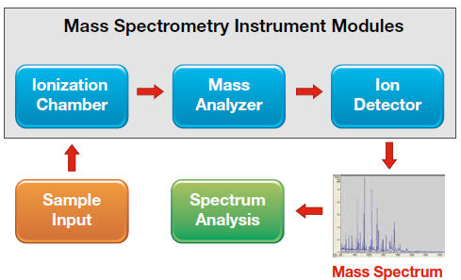

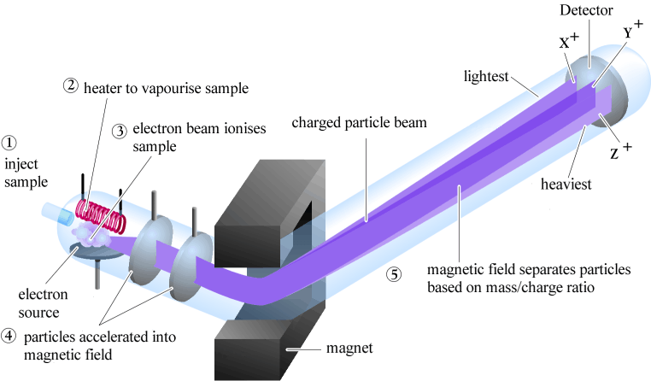

**Vaporization and Ionization techniques (processes)**

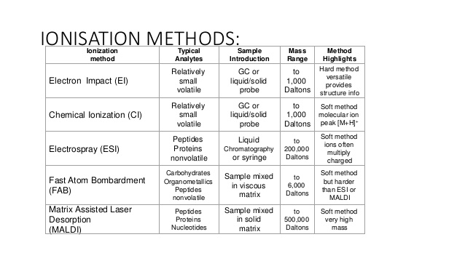

1. **Electron Impact (EI)**

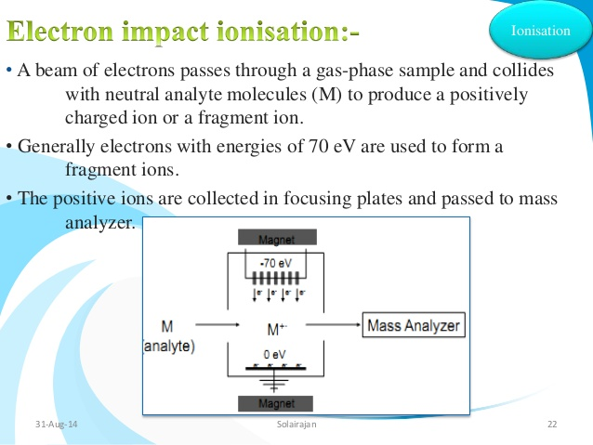

* Relatively harsh technique
* bombardment by using stream of electrons ⇒ sample ionized
* electrons from a metallic filament and accelerated through a potential difference (energy

of 70 eV ⇒ 6.75 x 103 KJ mol -1)

* least tightly held electron list giving radical cation.

M + e- → M+ + 2 e-

* ease of electron loss: Ione pair > π - bonded pair > δ - bonded pair

1. **Chemical Ionization (CI)**

* Same as EI but ionization takes place on a reagent gas (e.g. ammonia or methane)
* Sample ionized by a strong acid produced by the ionization of the reagent gas.

e.g. 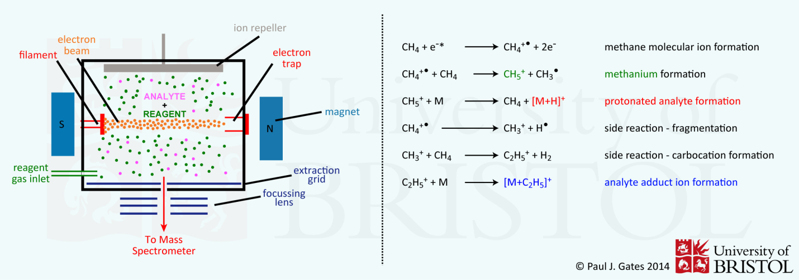

* Usually gives [M + 1] ion
* Fragmentation less than in E1

1. **Fast Atom Bombardment (FAB)**

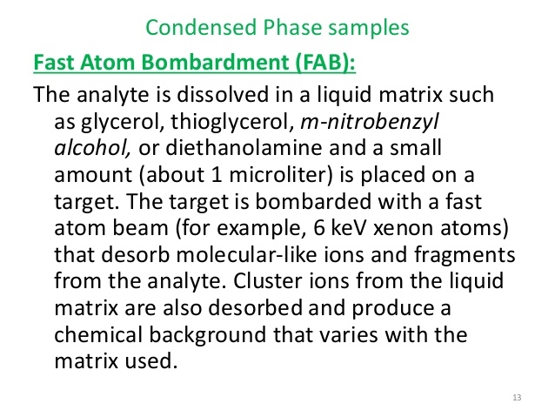

* “soft” method ⇒ less ionization
* Does not require sample to be volatile unlike CI & EI
* Bombardment of a solution of the analyte in a matrix (e.g. 2 – nitrobenzyl alcohol or propane -1, 2, 3 – triol) with a bean of fast moving atoms generally Xenon atoms ( 6 – 9 eV, 580 – 870 KJ mol-1).
* Transfer of energy from Xe atoms to matrix leads to the breaking of intermolecular bonds and the desorption of the analyte (as an ion) into the gas phase.
* Gives [M + I]+ peaks (corresponds to MH+)
* Little fragmentation

1. **MALDI**

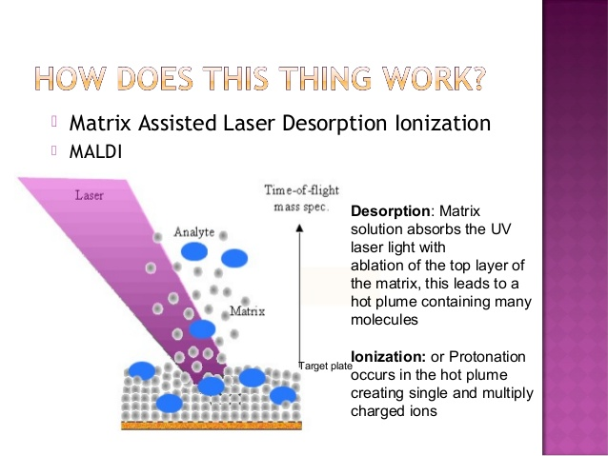

**Fragmentation processes**

⇒ Peak with largest $m/z$ value ⇒ molecular ion (M++ or parent ion.

⇒ Peaks with smaller $m/z$ values represent fragments of the compound.

⇒ The base peak is the one with the greatest abundance and assigned a relative abundance

of 100%.

Alkanes

e.g.

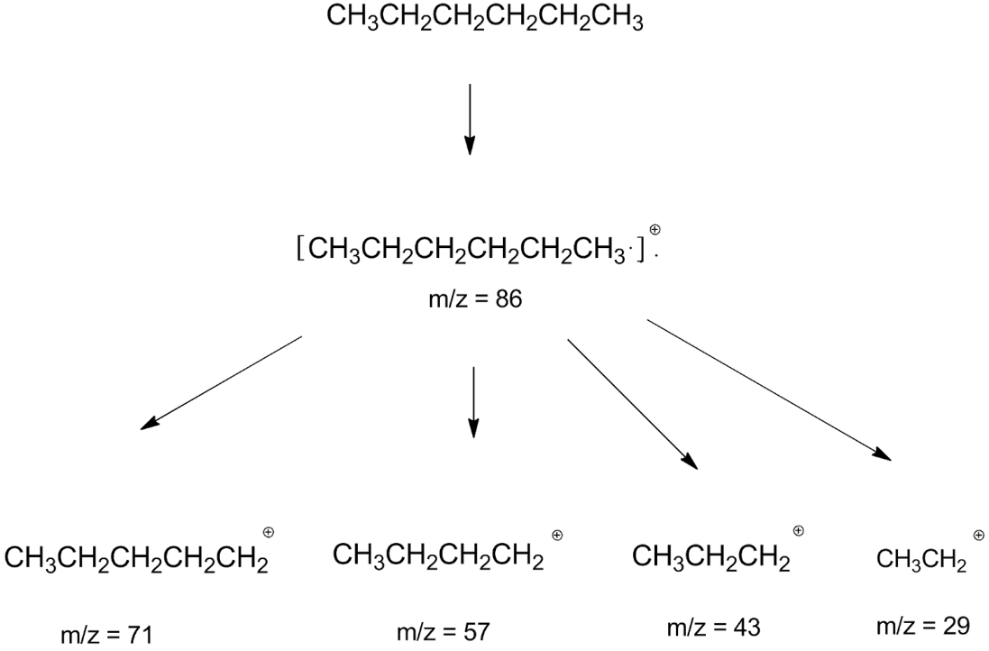

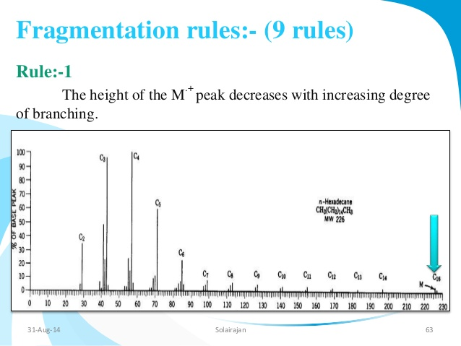

Branched:

E.g.

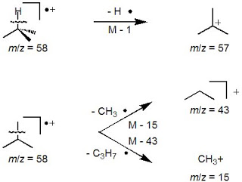

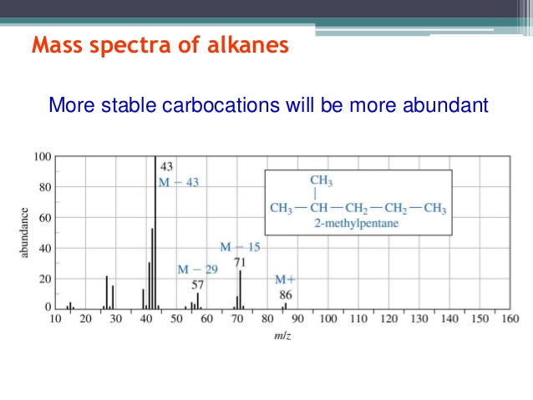

**NB:** Order of Stability

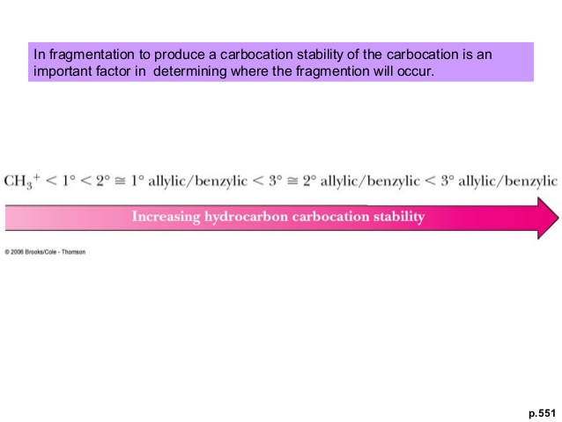

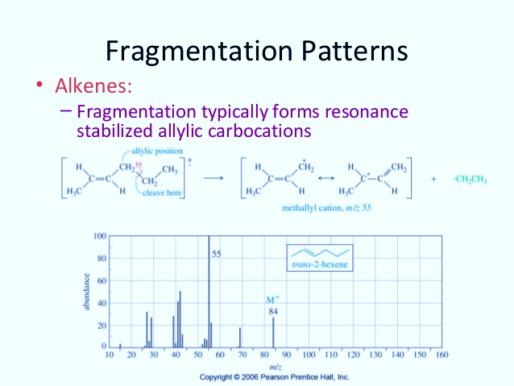

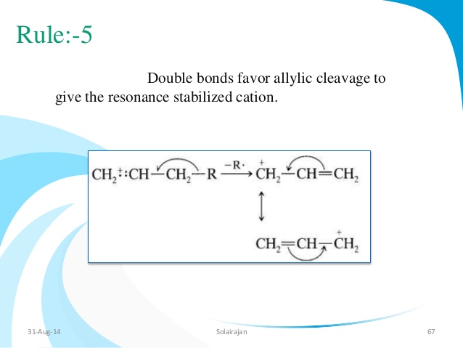

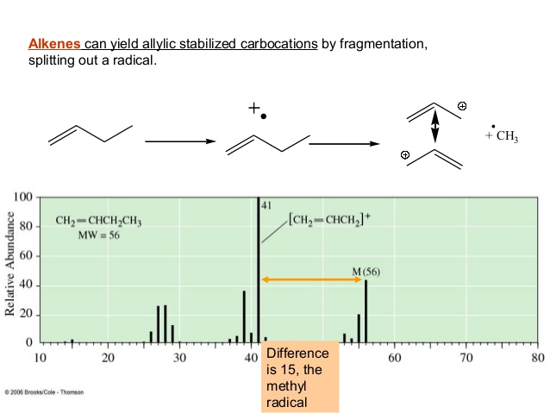

Cleavage of the α, β - bond adjacent to a heteroatom

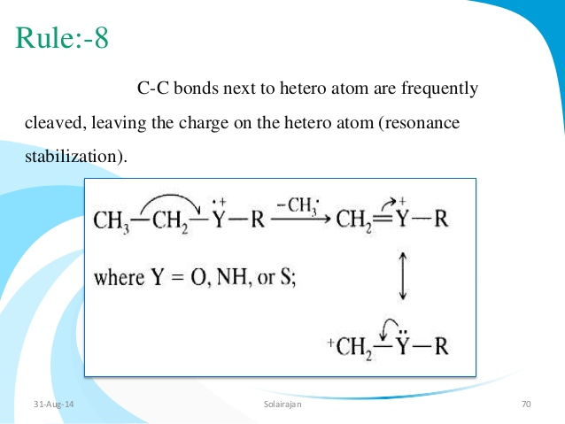

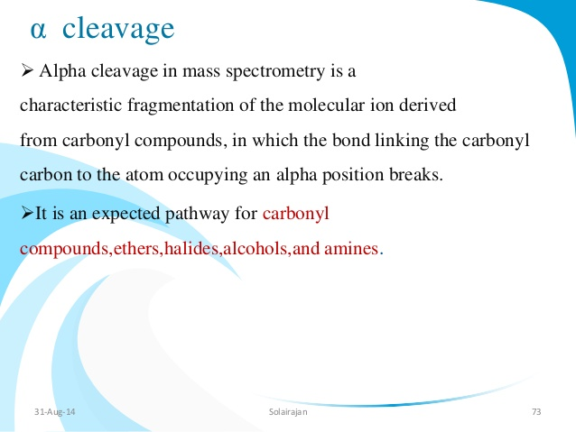

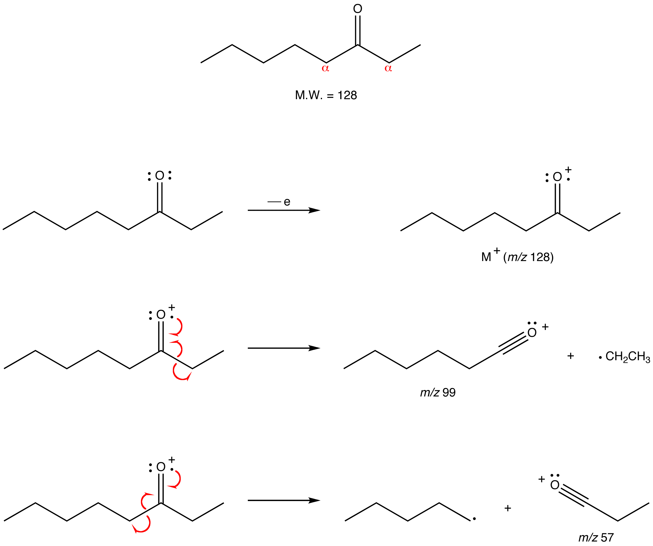

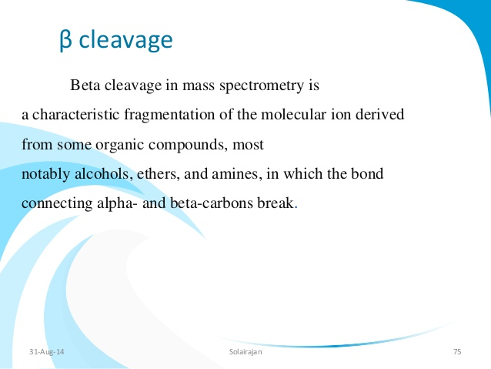

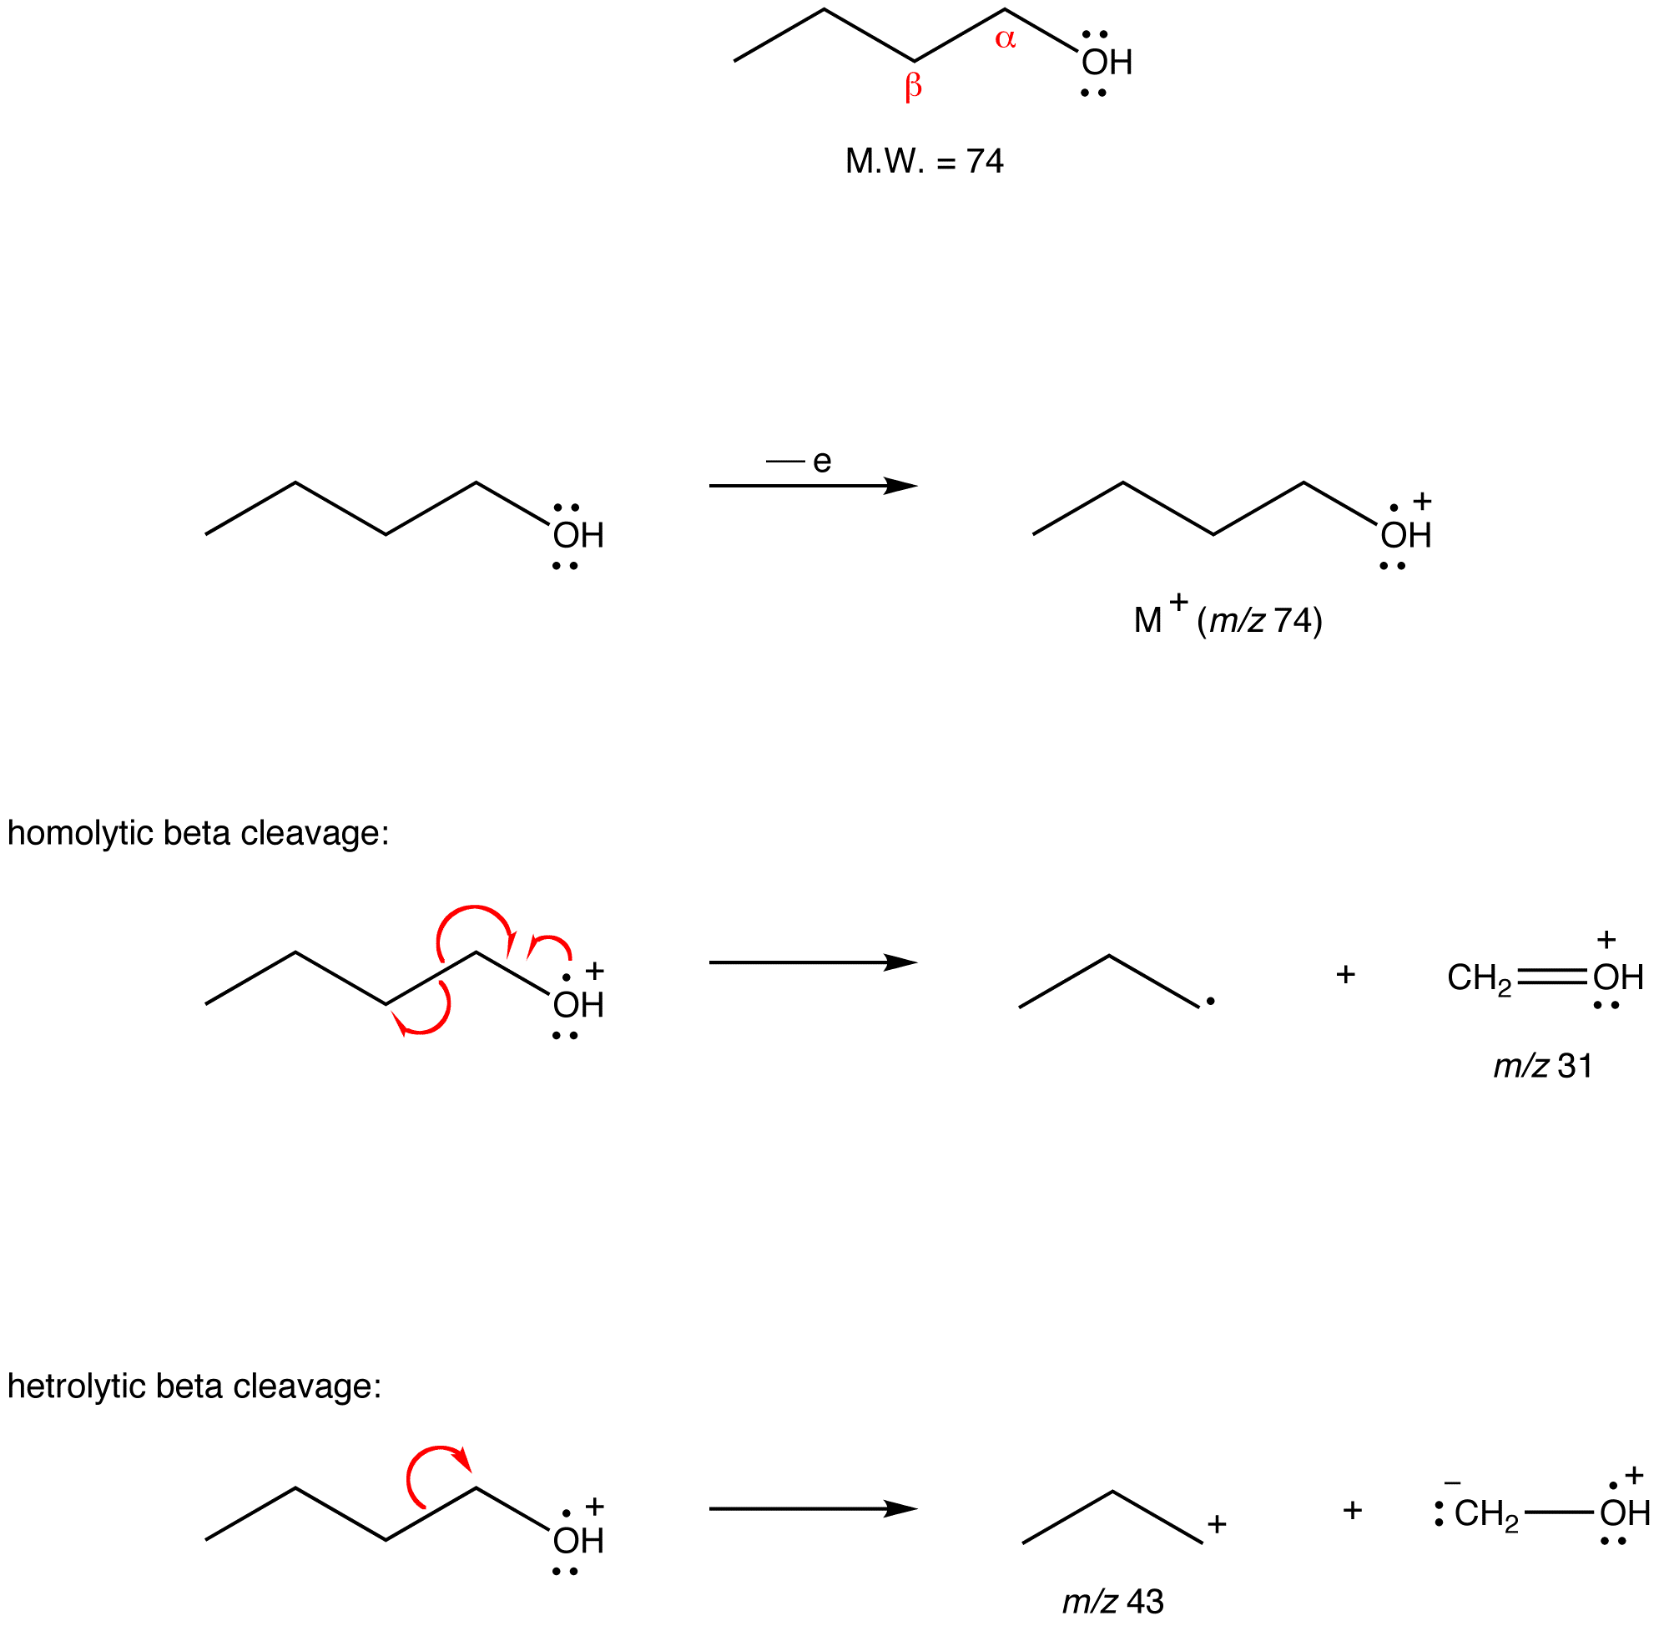

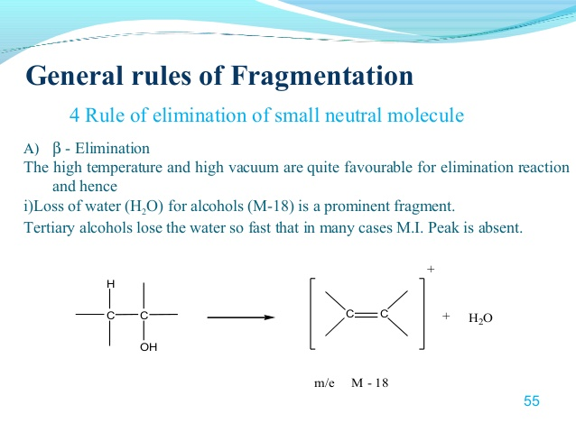

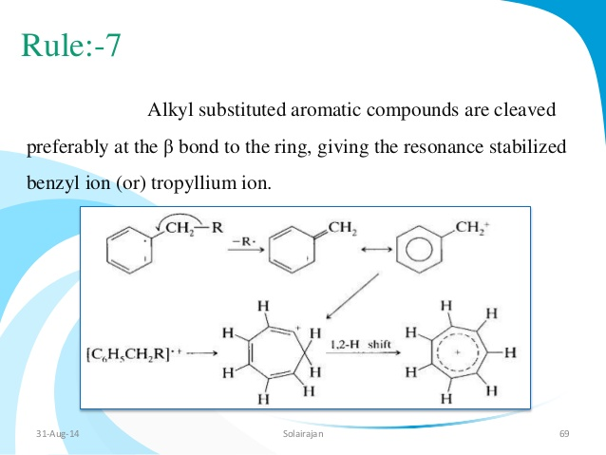

McLafferty rearrangement

* Six – membered ring transition
* Common in carbonyl compounds
* Hydrogen atom on the γ - carbon to the carbonyl.

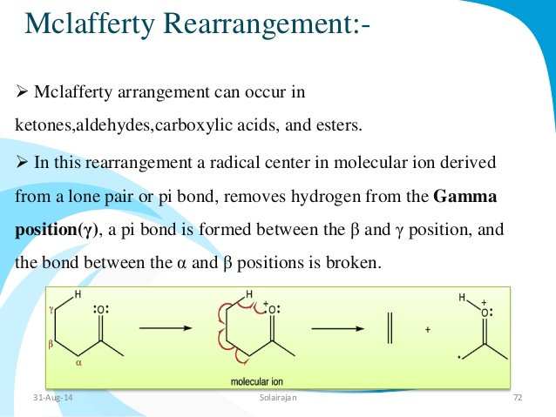

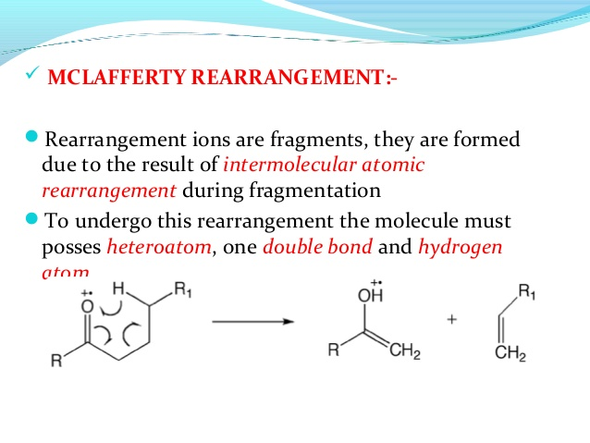

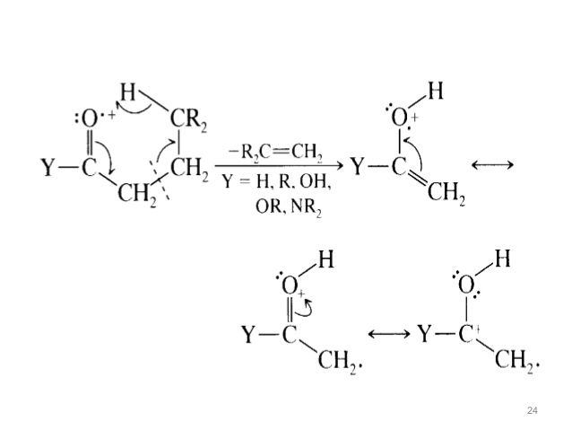

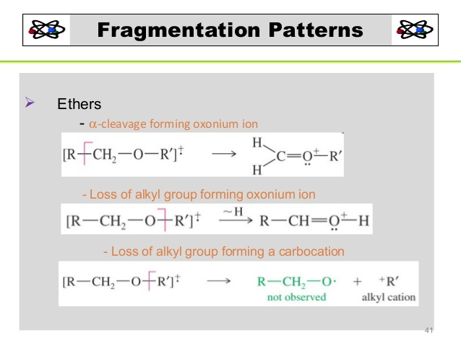

Retro – Diels – Alder Process

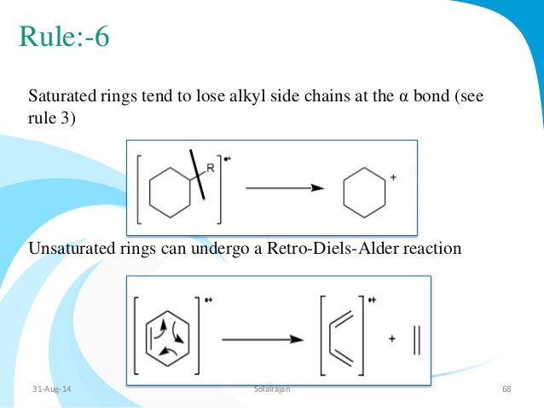

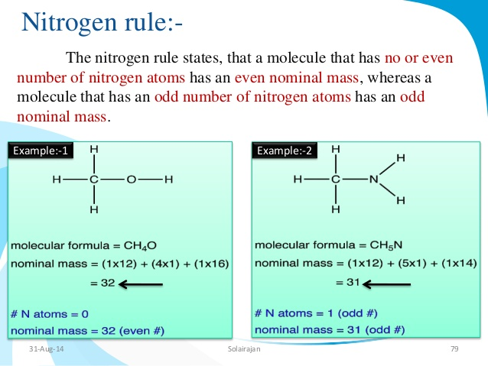

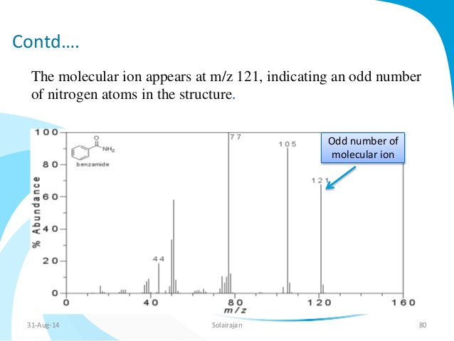

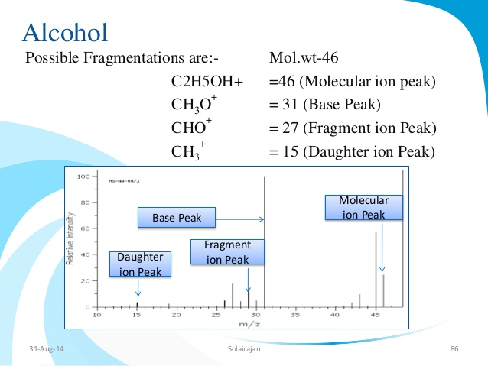

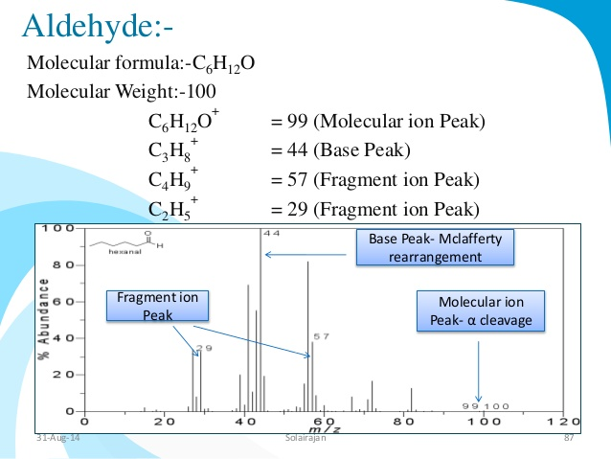

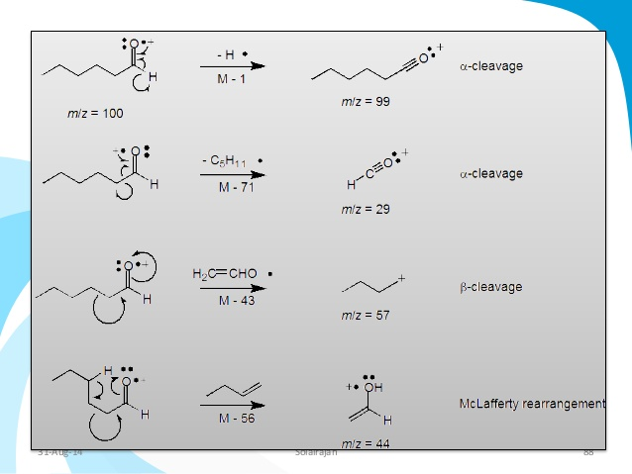

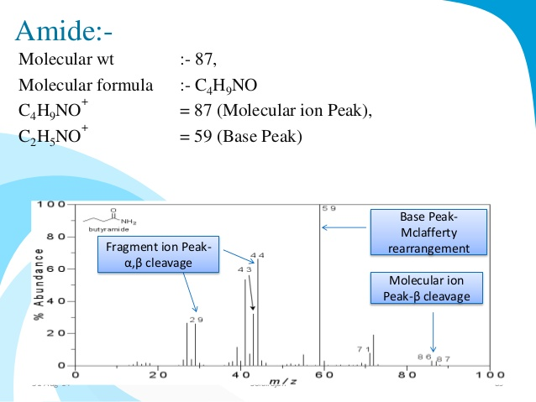

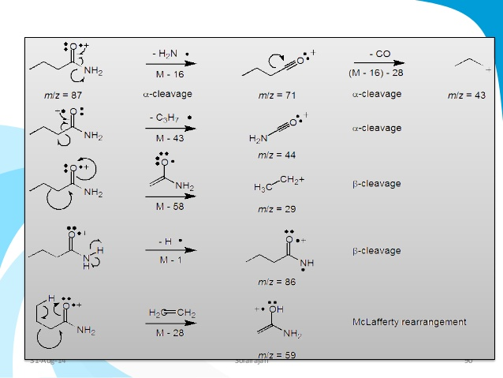

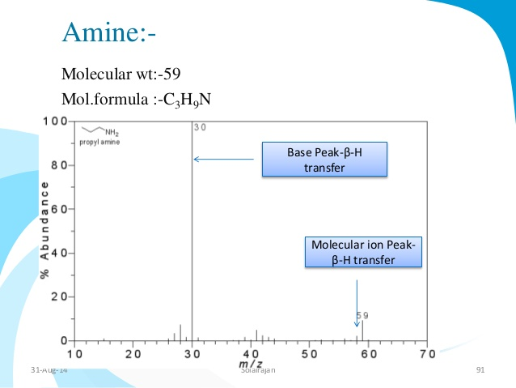

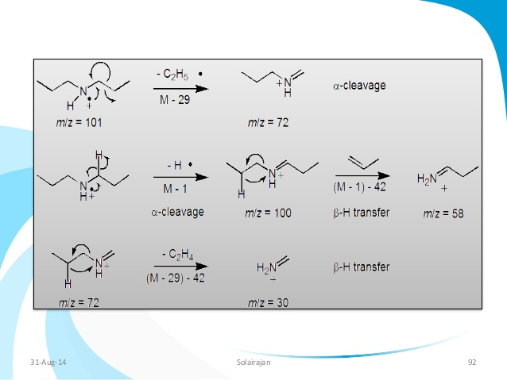

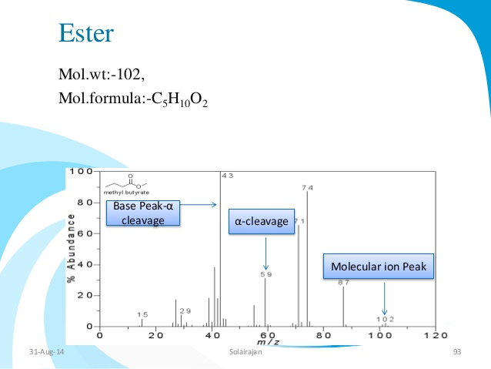

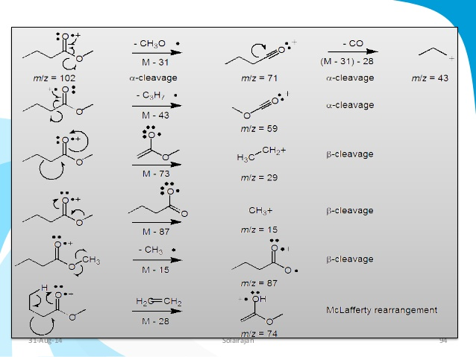

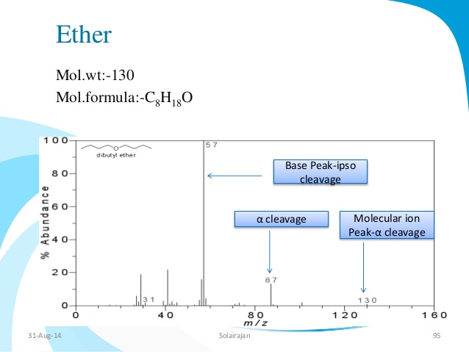

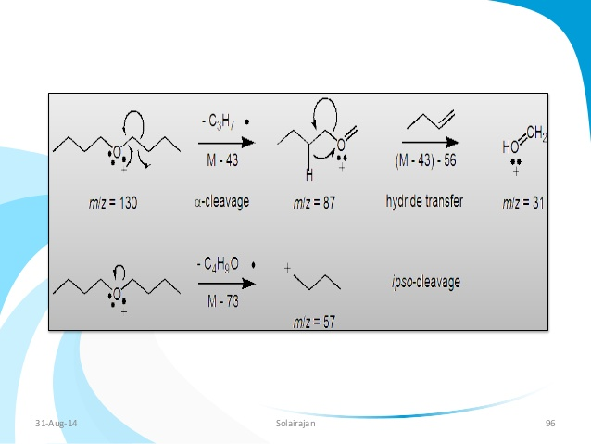

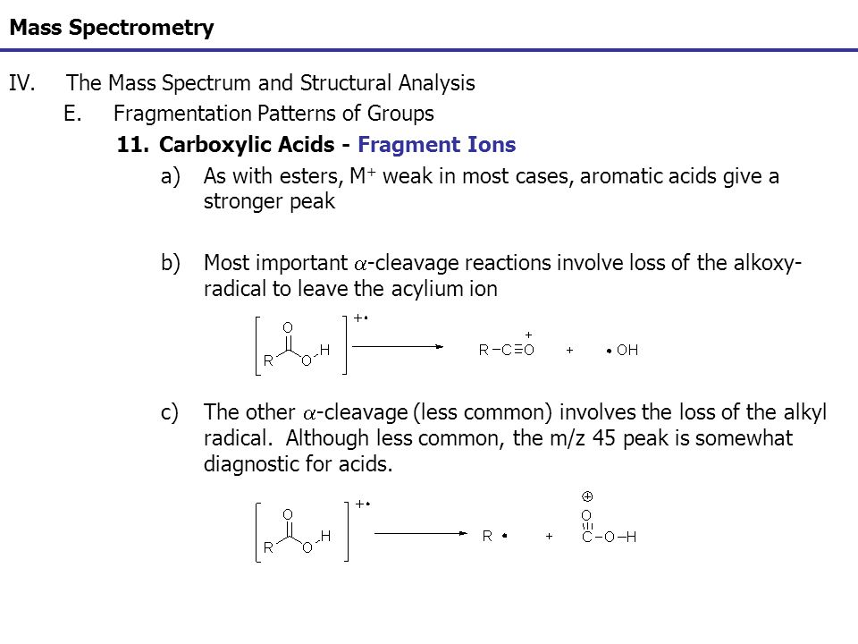

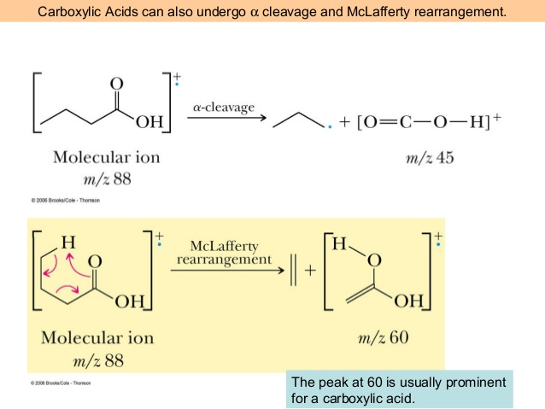

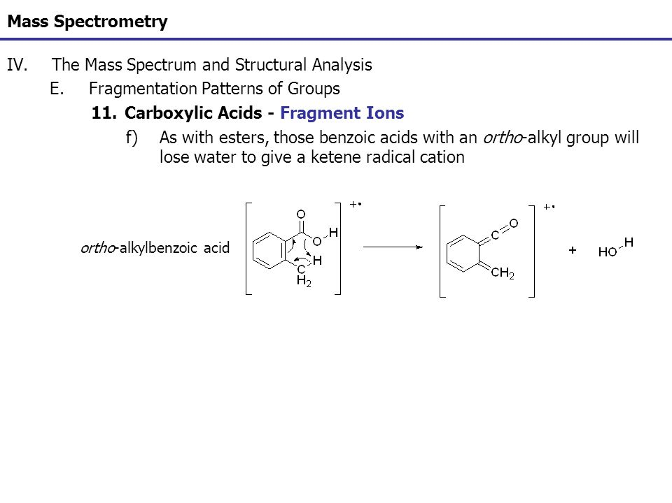

**Isotopic Peaks**

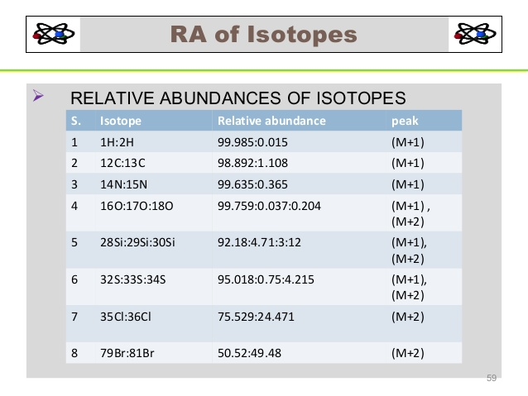

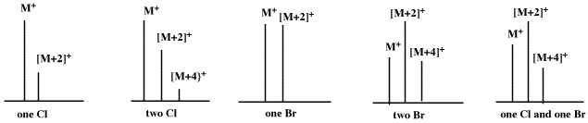

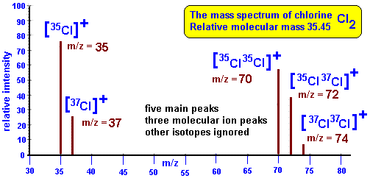

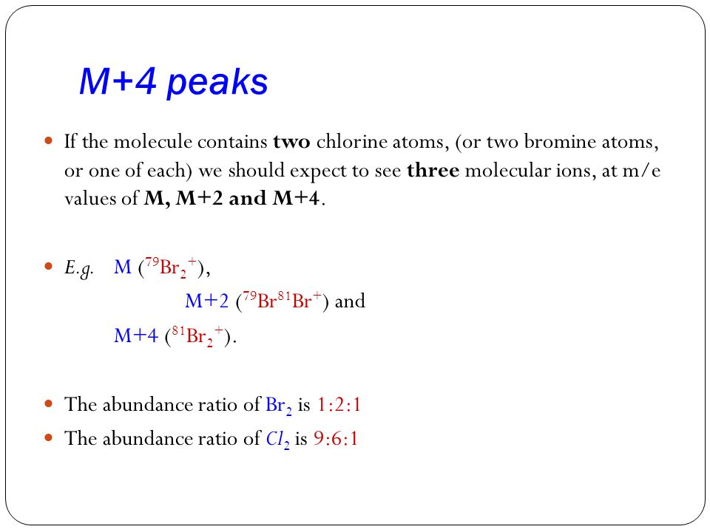

3 Brome atoms: m , m + 2 , m + 4 , m + 6

1 : 3 : 3 : 1

Relative contributions

(a + b)n where a & b are the relative abundances of the isotopes and n is the number of these atoms in the ion.

For 3 chlorine atoms: a3 + 3a2 b + 3ab2 + b3

**High – Resolution Mass Spectrometer**

* Nominal mass ⇒ mass to the nearest whole number
* High – resolution ⇒ determine exact mass to an accuracy of one part in 10,000

